**Introduction to NetTracer3D:**

As computational processing and ML-assisted segmentation tools for biological imaging data have improved significantly in recent years, there is now greater potential for analysis for large 3D biological images, such as those generated by light sheet fluorescence microscopy or resectioning. However, opportunities for analytical quantification of large 3D data is somewhat limited at the moment, with most analysis being focused on object-to-object colocalization that says nothing about 3D structure. In an effort to analyze 3D lightsheet images of human kidney tissue, we developed NetTracer3D, a Python tool that allows the user to create and analyze mathematical networks between different biological objects, such as cells or functional tissue units, that are joined together by some common media, such as nerves or blood vessels. NetTracer3D does not execute directly on images, but requires the objects in question to be segmented first with 3D segmentation tools, such as Cellpose or Labkit. Unique to NetTracer3D is the ability to tie mathematical network analysis to insights about 3D morphology of biological tissue. NetTracer3D was developed by Liam McLaughlin while working for Dr. Sanjay Jain at Washington University School of Medicine.

**Licensing**

*NetTracer3D is freely available for academic and nonprofit use (including alteration and forking) and can be obtained from Liam McLaughlin (boom2449@gmail.com) OR with pip (pip install nettracer3d), provided that the following citation is included in any abstract, paper, or presentation utilizing NetTracer3D.*

*Three Dimensional Multiscalar Neurovascular Nephron Connectivity Map of the Human Kidney Across the Lifespan*

*Liam McLaughlin, Bo Zhang, Siddharth Sharma, Amanda L. Knoten, Madhurima Kaushal, Jeffrey M. Purkerson, Heidy Huyck, Gloria S. Pryhuber, Joseph P. Gaut, Sanjay Jain*

*bioRxiv 2024.07.29.605633; doi: https://doi.org/10.1101/2024.07.29.605633*

*Commercial use is available for a fee. Copyright © is held by Washington University. Please direct all commercial requests for licensing, information, and limited evaluation copies to Washington University's Office of Technology Management at OTM@wustl.edu.*

**Installation:**

NetTracer3D is best used when its methods and functions are executed from an external main Python script. First, make sure Python 3 is installed in your system and on the path. Next, NetTracer3D can be incorporated into your Python3 environment with pip by calling the following code. The first is the basic version that only uses CPU:

pip install nettracer3d

However, it will be better to install the GPU version, enabling much faster processing. To use the GPU version, you will need to have a CUDA toolkit environment set up on your machine. To install the GPU version for CUDA versions 12x, use this command:

pip install nettracer3d[CUDA12]

If you instead have CUDA versions 11x, you can use this command instead:

pip install nettracer3d[CUDA11]

Now, we can utilize NetTracer3D in an external script or notebook by importing it as so:

from nettracer3d import nettracer as n3d

For clarity of what is happening behind the scenes when NetTracer3D executes its central network finding script, the basic steps within the algorithm are described below:

**Explanation of Network Finding Algorithm:**

1. We begin with the image below, representing a 3D tiff containing binary segmented node-objects (green spheres) and binary segmented edge objects (red filaments). These nodes could be, for example, a cluster of cells, while the edge could be a capillary.

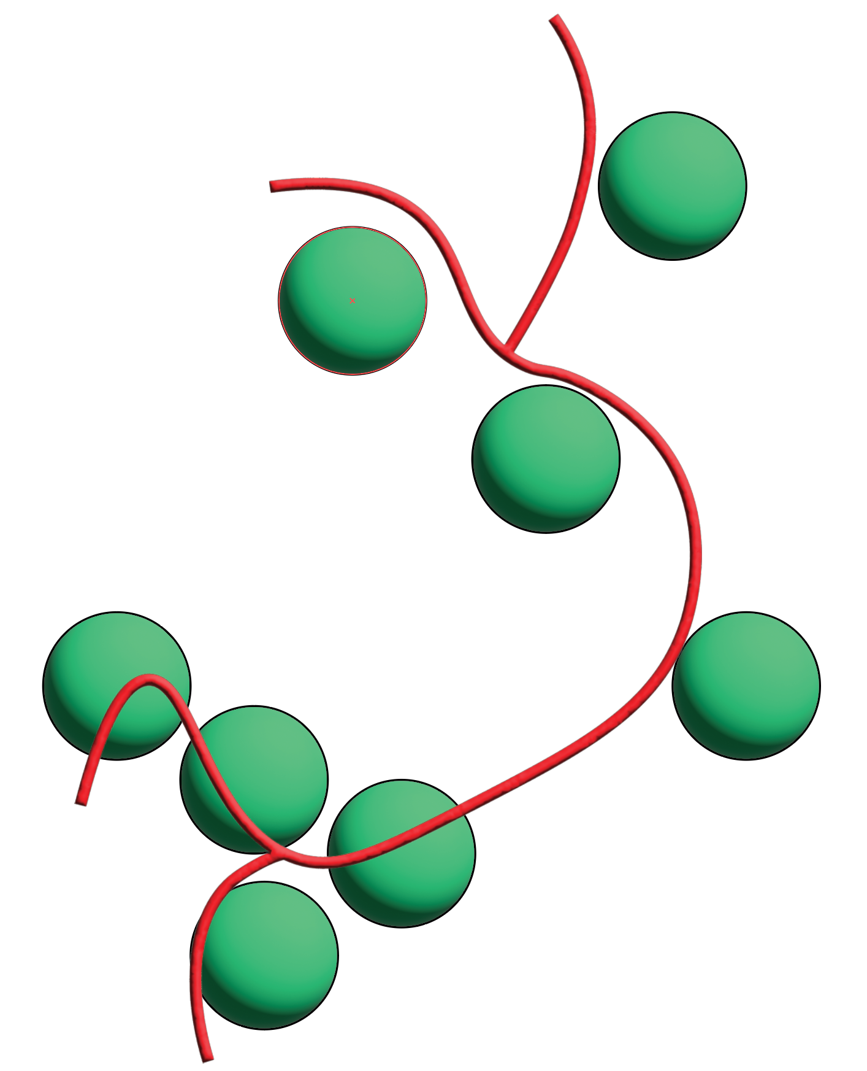

1. We convert the .tif into a 3D array and assign a unique numerical label to each node. Additionally, we optionally allow each node to expand in 3D space, with the search region (shown in blue) maintaining the node’s numerical label. This expansion is powered by a distance transformation relative to the nodes, enabling each expansion region to find which label it corresponds to, and is conceptually similar to a Voronoi diagram but with cells corresponding to 3D objects rather than points, and the size of cells being controllable by the user, rather than for the entire array.

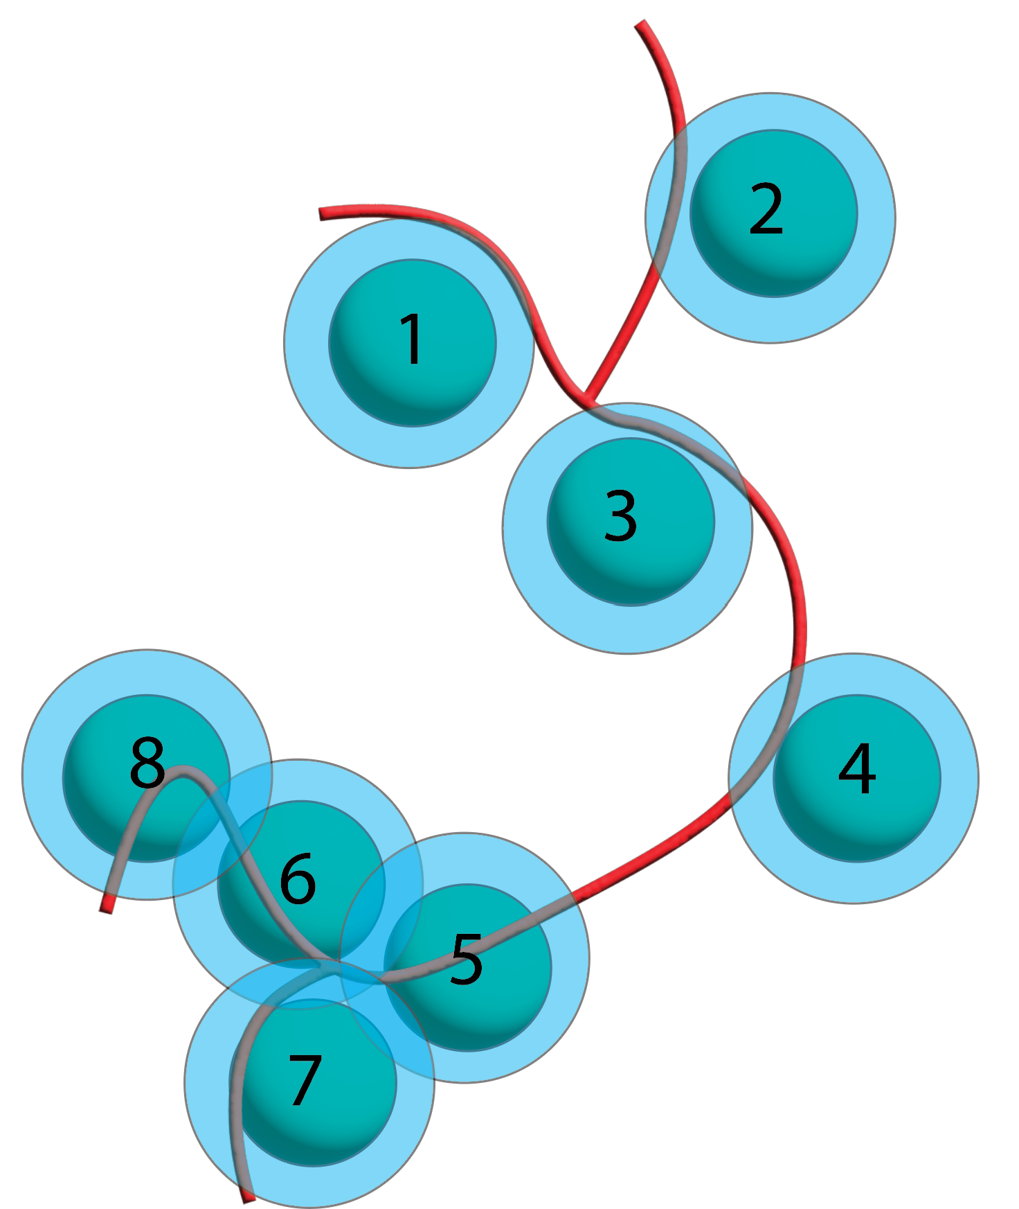

1. Next, we break the edges by their relationship to the node search regions and assign each broken component a label. In empty space between search regions, edges are broken into ‘outer edges’ that maintain their entire shape except those points that exist within a search region (except a single pixel overlap at the search region’s surface). In the inner space within search regions, edges are broken into ‘inner edges’ that only exist in those points where search regions are bordering one another, resulting in the edge being reduced to small pieces. These border regions can be obtained from the gaussian blur of the search region array.

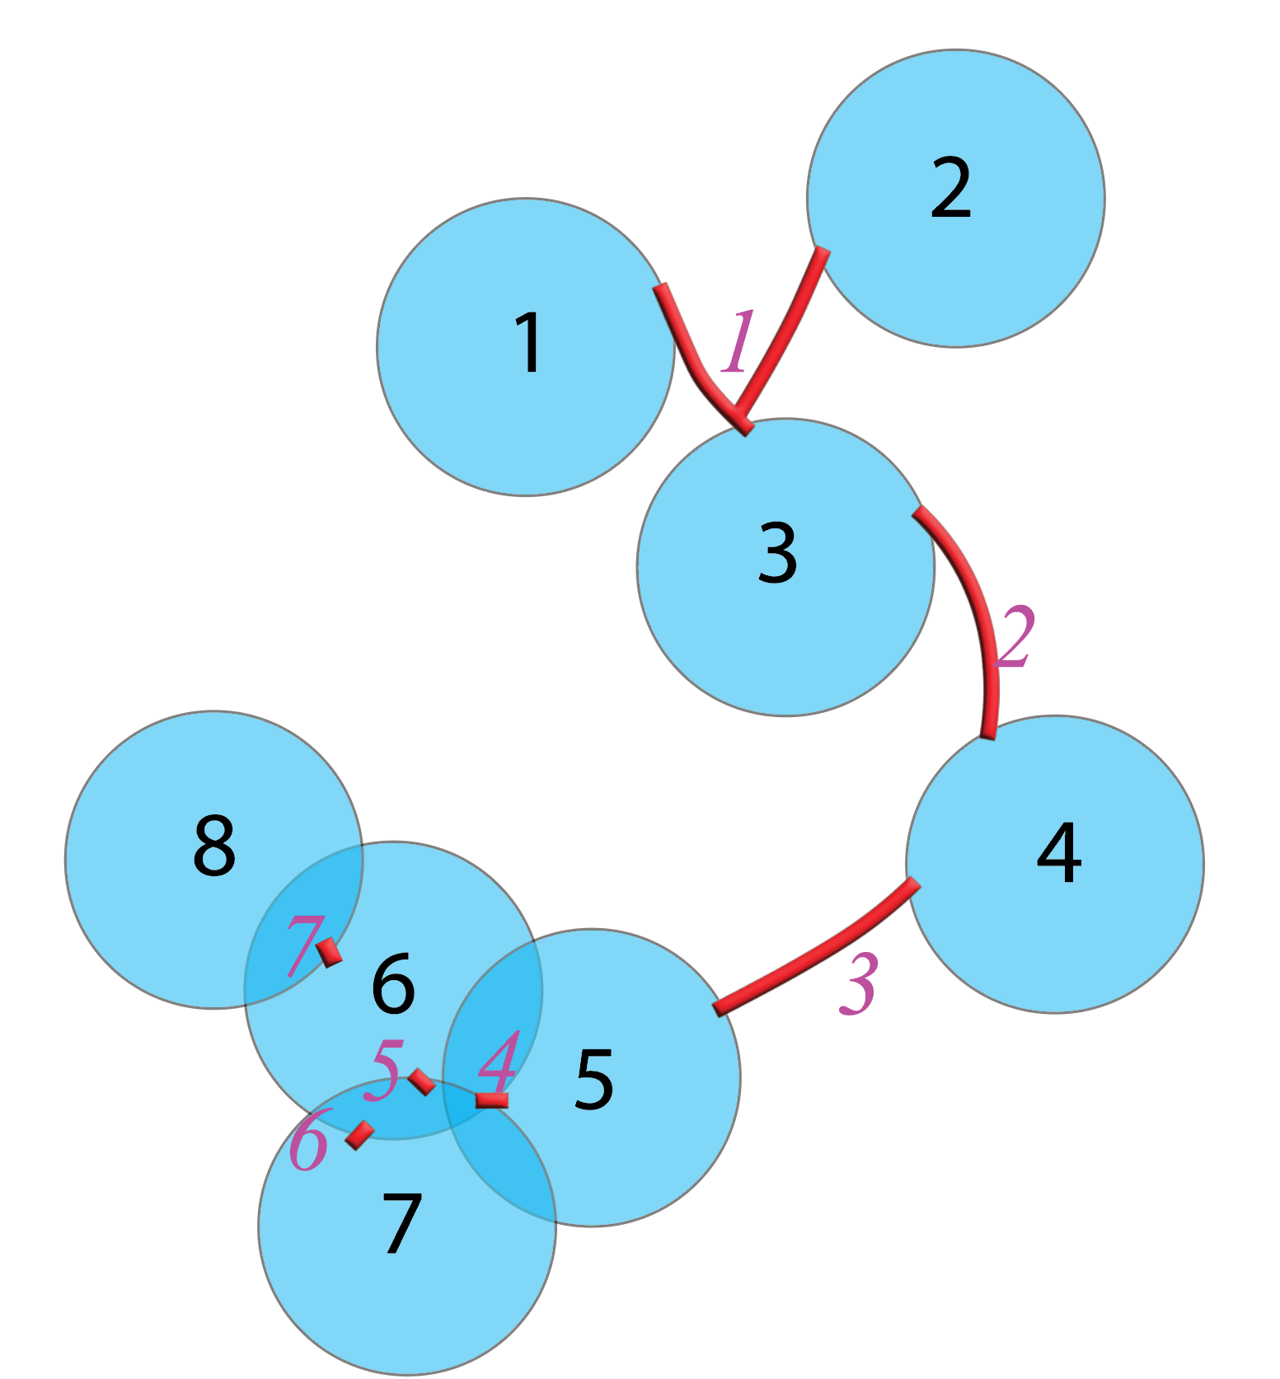

1. We isolate the overlap regions between search regions and edges. By looking at the numerical IDs of the overlap, we know which nodes interact with which edge.

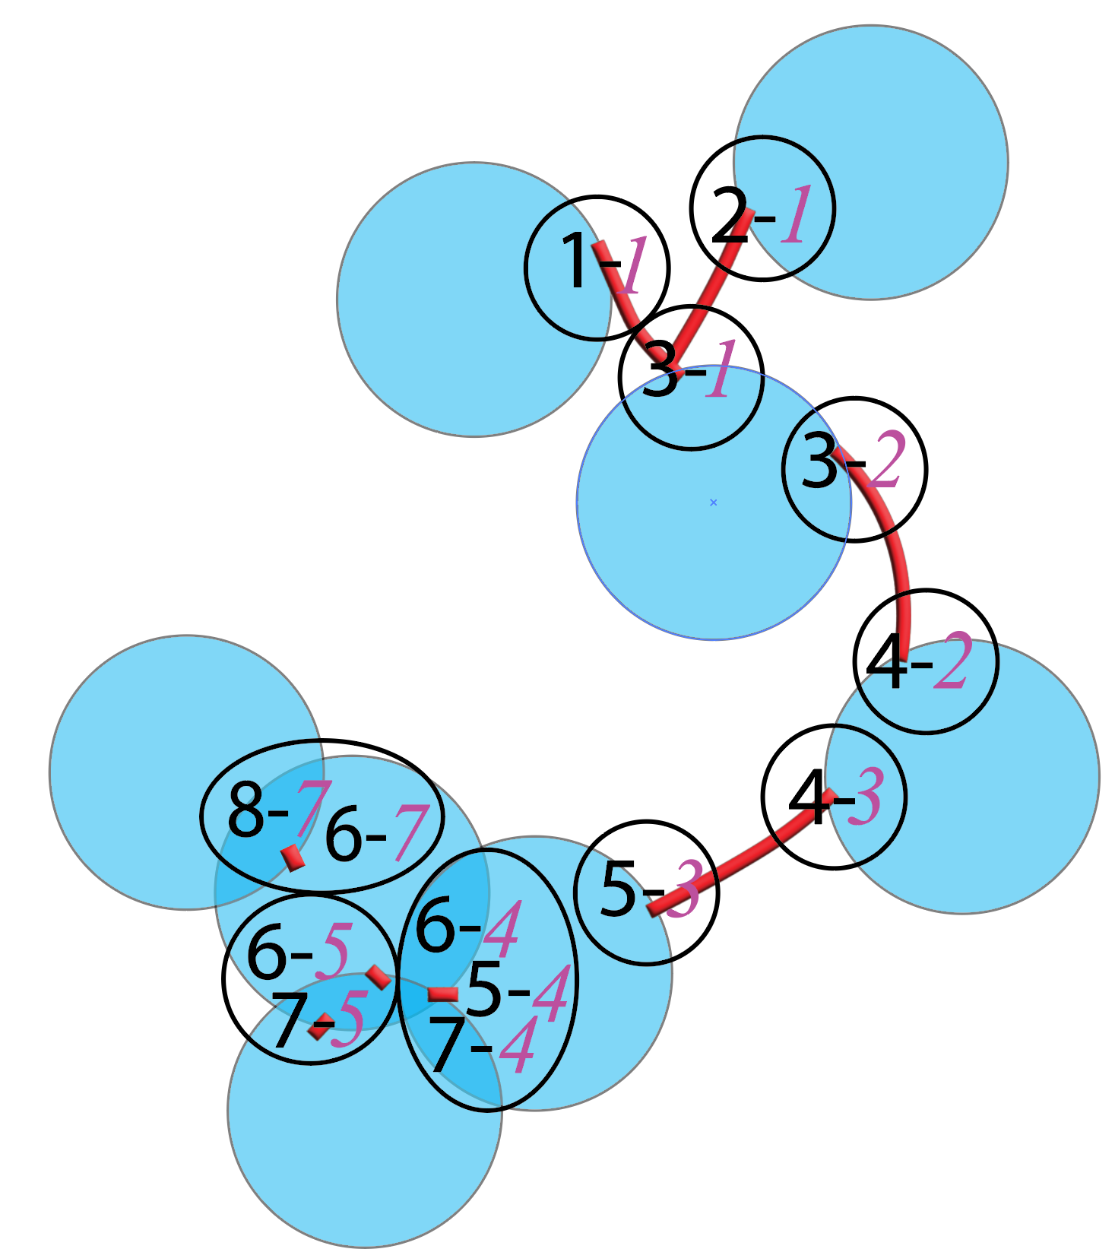

1. Finally, we sort through the node/edge overlaps and assign all nodes that share the same edge as ‘connected’, allowing us to generate a mathematical network from these 3D segmentations.

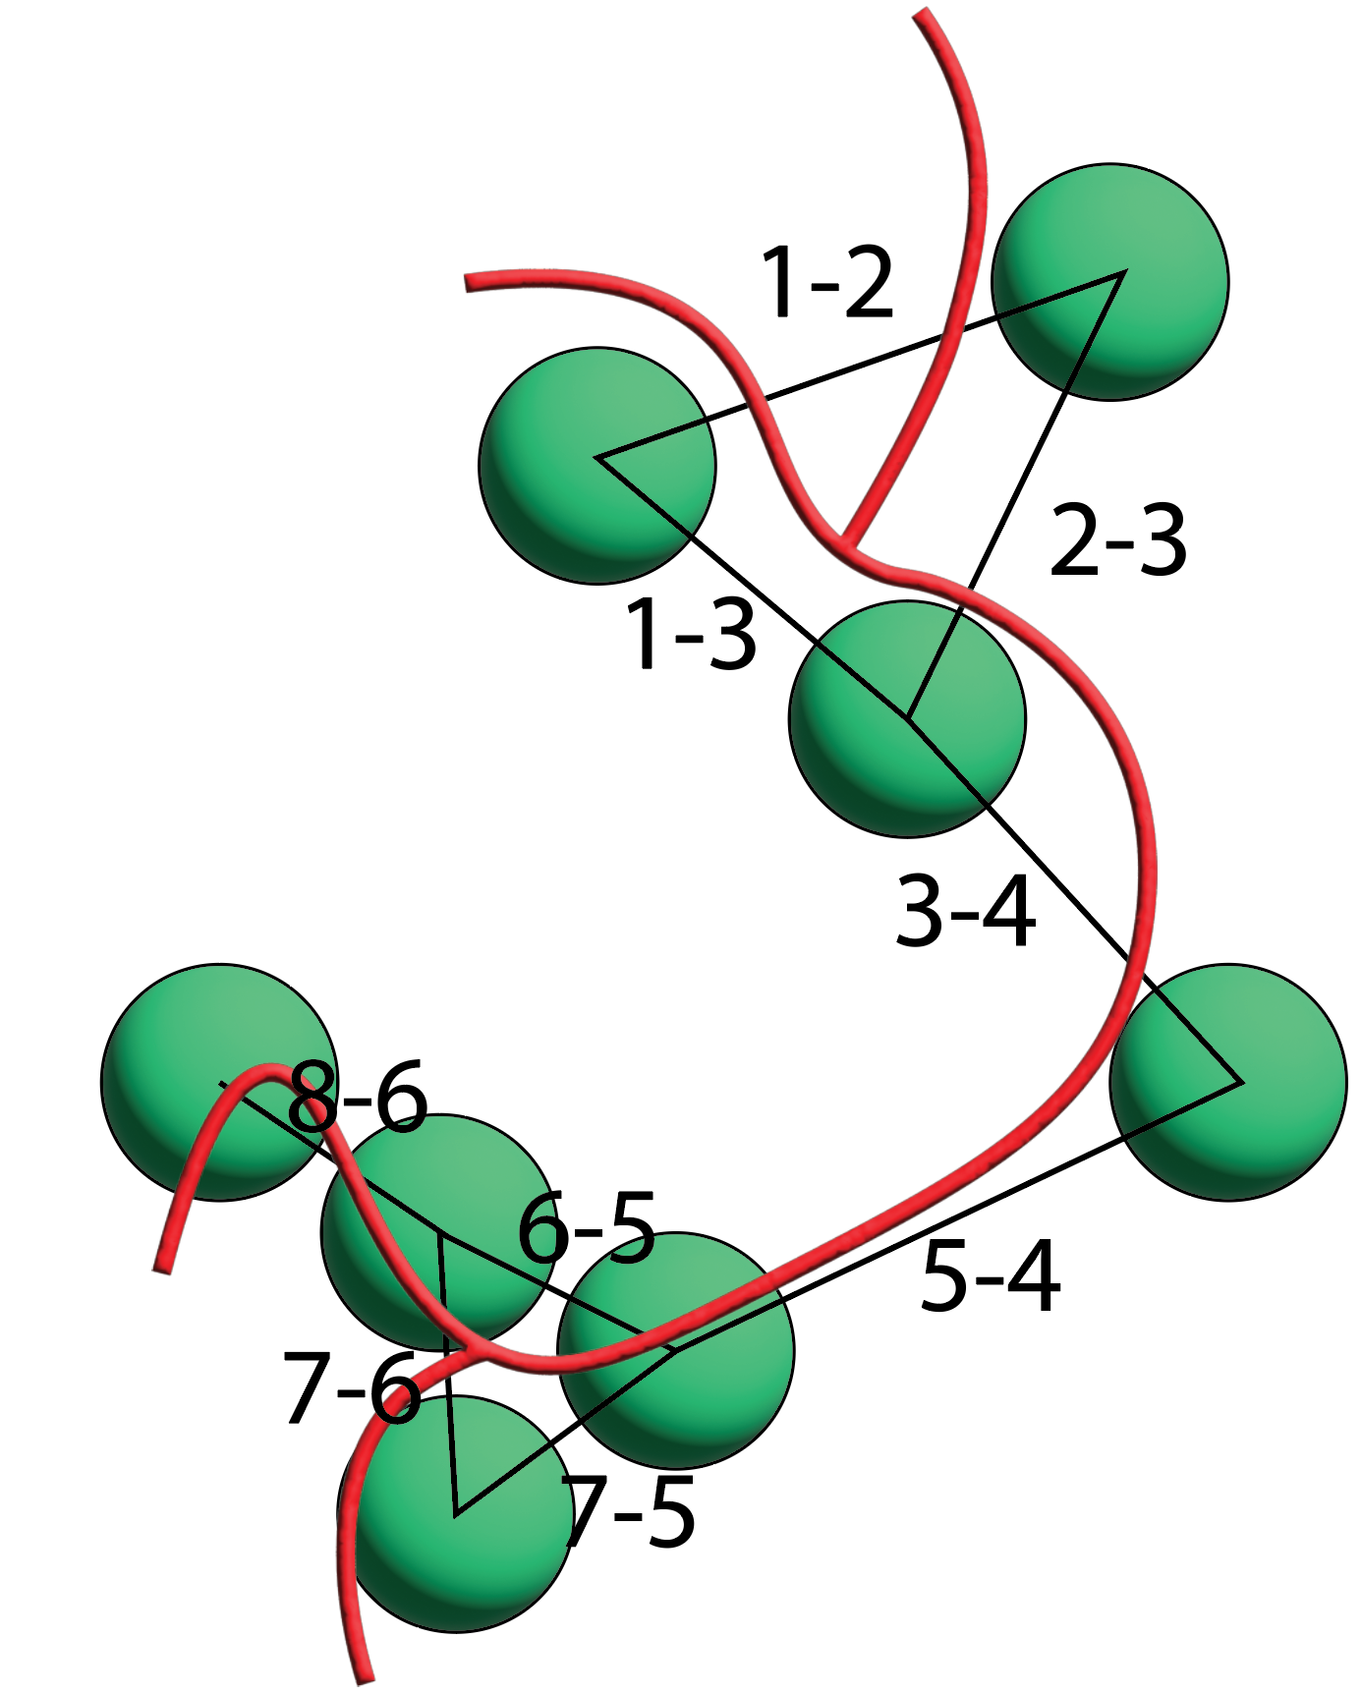**­**

**Introduction to the Network_3D Class:**

NetTracer3D is best utilized when working with the Network_3D class, which allows us to initialize Network_3D objects containing networks analyzable with the Python NetworkX module, as well as properties pertaining to related three-dimensional information.

The initialization method, demonstrating the class attributes and their default settings, is documented below.

|  |
| --- |
| class Network_3D:  """A class to store various components of the 3D networks, to make working with them easier"""  def __init__(self, nodes = None, network = None, xy_scale = 1, z_scale = 1, network_lists = None, edges = None, search_region = None, node_identities = None, node_centroids = None, edge_centroids = None):  """  Constructor that initiates a Network_3D object. Note that xy_scale and z_scale attributes will default to 1 while all others will default to None.  :attribute 1: (ndarray) _nodes - a 3D numpy array containing labelled objects that represent nodes in a network  :attribute 2: (G) _network - a networkx graph object  :attribute 3: (float) _xy_scale - a float representing the scale of each pixel in the nodes array.  :attribute 4: (float) _z_scale - a float representing the depth of each voxel in the nodes array.  :attribute 5: (list) _network_lists - an internal set of lists that keep network data  :attribute 6: (ndarray) _edges - a 3D numpy array containing labelled objects that represent edges in a network.  :attribute 7: (ndarray) _search_region - a 3D numpy array containing labelled objects that represent nodes that have been expanded by some amount to search for connections.  :attribute 8: (dict) _node_identities - a dictionary that relates all nodes to some string identity that details what the node actually represents  :attribute 9: (dict) _node_centroids - a dictionary containing a [Z, Y, x] centroid for all labelled objects in the nodes attribute.  :attribute 10: (dict) _edge_centroids - a dictionary containing a [Z, Y, x] centroid for all labelled objects in the edges attribute.  :returns: a Network-3D classs object.  """  self._nodes = nodes  self._network = network  self._xy_scale = xy_scale  self._z_scale = z_scale  self._network_lists = network_lists  self._edges = edges  self._search_region = search_region  self._node_identities = node_identities  self._node_centroids = node_centroids  self._edge_centroids = edge_centroids |

All of these attributes are available as properties that can be publicly get/set. The properties have the same name as their attribute, except with the leading underscore removed. These properties are described below:

**Property 1 – nodes**: The nodes property contains a 3D numpy array containing nodes, where the space occupied by each node is indicated by a unique numerical value. A node is simply an object in a network. For example, if we modeled the internet as a network, a node could be a server. Pertaining to NetTracer3D, a node could be some biological object we want to evaluate, such as a cell or an FTU such as an alveolus. For example, an array with three nodes will have three objects constructed of array indices containing the values 1, 2, and 3. It is up to the user to segment the nodes from their biological data as either binary signal or signal that has been prelabelled into objects as described. There are a variety of free tools that can be used for flexible segmentation, such as Cellpose or ImageJ with the Labkit plugin. If your nodes are binary, they will have to be labelled either prior or during Network_3D object generation, which NetTracer3D can provide some assistance in doing.

**Property 2 – network**: The network property contains the network information, stored as a NetworkX undirected graph object. NetworkX is a powerful network visualization and analysis Python package, whose plethora of functions can be applied as needed to analyze the network property of a Network_3D object. (NetworkX documentation: <https://networkx.org/documentation/stable/reference/index.html>). Note that when generating Network_3D objects, duplicate connections between nodes along separate pathways result in weighted networks, however this factor can be undone with the remove_edge_weights() method.

**Property 3 – xy_scale:** The xy_scale property contains the scale of pixels as a float. In a biological image or similar, each pixel may be representative of some true unit of distance, such as microns. For example, an image where every pixel is 0.5 µm long should have its xy_scale property set to ‘0.5’. Note that NetTracer3D presumes that the x and y scale of any image will be equal, as is the case for most microscopic imaging.

**Property 4 – z_scale:** The z_scale property contains the scale of voxel depths as a float. In microscopy, three-dimensional pixels are known as voxels and contain a third z dimension which often differs in its true-distance scaling from the x/y dimensions. Consequently, z_scale is assigned as a separate property.

**Property 5 – network_lists:** The network_lists property is a list containing three sublists, with the first two containing the numerical IDs of paired node objects in the network, and the third containing the numerical ID of the corresponding edge object. While the information stored in the network property is designed for utilization with NetworkX, the network_lists property instead stores network information in three basic lists that may be manipulated in a more rote manner. The list indexed in location zero contains a first set of nodes IDs (their numerical ID equivalent to their value in the nodes property array), while the list indexed in the one location contains a second set of node IDs. All nodes in both of these sublists that share the same index are considered connected within the network. The third list, indexed in the two location, contains the numerical IDs of edges. Correspondingly, the edge at any given index in this sublist is the edge that was used to establish the node-node connection of those nodes at the same index in the two nodes lists. The network_lists property is mostly used internally, but it can provide a more straightforward way to interact with the network.

**Property 6 – edges:** The edges property contains network edges in a 3D numpy array, spatially indexed as separate objects by unique numerical IDs. An ‘edge’ is simply a connection in a network. In the case of NetTracer3D, an edge will typically represent some real biological object that establishes some kind of connectivity between two node objects, such as a nerve or a blood vessel. The assignment of unique numerical edge IDs is decided based on their relationship with the nodes, with edges being generally split by nodes into discrete ‘before’ and ‘after’ segments. Note that the edges stored in the edges property may be manipulated during network generation, both as directed by the user to manage imaging artifacts, and to ease processing, and therefore may not exactly resemble the structure of the original binary mask. Like nodes, edges will have to be segmented elsewhere from their images as binary masks prior to the generation of a Network_3D object. Unlike nodes, edges will typically be passed during network generation as binary masks, with discrete edge labelling done by the algorithm itself, although it is possible to instead pass a pre-labelled edge mask if the user wishes.

**Property 7 – search_region:** The search region contains enlarged nodes in a 3D numpy array that retain the same numerical IDs as the array in the nodes property. Given that biological connectivity may frequently not involve direct contact, for example due to diffusive signaling of nerves or hormones from blood vessels, the user is recommended to create a search_region for their nodes, or otherwise only objects that directly overlap an ‘edge’ will be considered connected. The search_region allows the nodes to expand outwards and search for connections at some arbitrary distance.

**Property 8 – node_identities:** The node_identities property contains a dictionary where every node numerical ID is a key with a single value string representing what sort of real-world object that node represents. NetTracer3D allows the user to compare connectivity between objects labelled in separate segmentations, say from multiple imaging channels. For example, if I am imaging kidney and want to evaluate neural connectivity between glomerulus and proximal tubule, these can be segmented as two separate .tif images and merged into a single ‘nodes’ property during network generation. In such a case, the node_identities property will have a dictionary that will let the user and program know what node corresponds to what biological object.

**Property 9 – node_centroids:** The node_centroids property contains a dictionary where every node numerical ID is a key with a single value. The value itself is a three-element tuple containing the (Z, Y, X) location of the centroid for the corresponding node (as determined from the array in the nodes property). Once computed, the node_centroids can be used to rapidly evaluate the locations of nodes in the network.

**Property 10 – edge_centroids:** The edge_centroids property contains a dictionary where every node numerical ID is a key with a single value. The value itself is a three-element tuple containing the (Z, Y, X) location of the centroid for the corresponding edge (as determined from the array in the nodes property). Once computed, the edge_centroids can be used to rapidly evaluate the locations of edges in the network.

**Initializing a Network_3D Class and Generating Its Network:**

We will begin by importing the nettracer module from nettracer3d and initializing a new Network_3D object:

|  |
| --- |
| from nettracer3d import nettracer as n3d  my_network = n3d.Network_3D() |

At this stage, most of the attributes of the Network_3D object are set to None and must be computed from segmentations provided by the user. It will likely be easiest to compute all properties of a network 3D class simultaneously, which will enable use of all supporting methods for Network_3D objects. This will be accomplished with the calculate_all() method, as documented below:

|  |
| --- |
| def calculate_all(self, nodes, edges, xy_scale = 1, z_scale = 1, down_factor = None, search = None, diledge = None, inners = True, hash_inners = True, remove_trunk = 0, ignore_search_region = False, other_nodes = None, label_nodes = True, directory = None, GPU = True, fast_dil = False):  """  Method to calculate and save to mem all properties of a Network_3D object. In general, after initializing a Network_3D object, this method should be called on the node and edge masks that will be used to calculate the network.  :param nodes: (Mandatory; String or ndarray). Filepath to segmented nodes mask or a numpy array containing the same.  :param edges: (Mandatory; String or ndarray). Filepath to segmented edges mask or a numpy array containing the same.  :param xy_scale: (Optional - Val = 1; Float). Pixel scaling to convert pixel sizes to some real value (such as microns).  :param z_scale: (Optional - Val = 1; Float). Voxel depth to convert voxel depths to some real value (such as microns).  :param down_factor: (Optional - Val = None; int). Optional factor to downsample nodes and edges during centroid calculation to increase speed. Note this only applies to centroid calculation and that the outputed centroids will correspond to the full-sized file. On-line general downsampling is not supported by this method and should be computed on masks before inputting them.  :param search: (Optional - Val = None; int). Amount nodes should expand outward to search for connections. Note this value corresponds one-to-one with voxels unless voxel_scaling has been set, in which case it will correspond to whatever value the nodes array is measured in (microns, for example). If unset, only directly overlapping nodes and edges will find connections.  :param diledge: (Optional - Val = None; int). Amount to dilate edges, to account for imaging and segmentation artifacts that have brokenup edges. Any edge masks that are within half the value of the 'diledge' param will become connected. Ideally edges should not have gaps,  so some amount of dilation is recommended if there are any, but not so much to create overconnectivity. This is a value that needs to be tuned by the user.  :param inners: (Optional - Val = True; boolean). Will use inner edges if True, will not if False. Inner edges are parts of the edge mask that exist within search regions. If search regions overlap,  any edges that exist within the overlap will only assert connectivity if 'inners' is True.  :param hash_inners: (Optional - Val = True; boolean). If False, all search regions that contain an edge object connecting multiple nodes will be assigned as connected.  If True, an extra processing step is used to sort the correct connectivity amongst these search_regions. Can only be computed when search_regions property is set.  :param remove_trunk: (Optional - Val = 0; int). Amount of times to remove the 'Trunk' from the edges. A trunk in this case is the largest (by vol) edge object remaining after nodes have broken up the edges.  Any 'Trunks' removed will be absent for connection calculations.  :param ignore_search_region: (Optional - Val = False; boolean). If False, will use primary algorithm (with search_regions property) to find connections. If True, will use secondary algorithm (with nodes) to find connections.  :param other_nodes: (Optional - Val = None; string). Path to either a tif file or a directory containing only additional node files to merge with the original nodes, assuming multiple 'types' of nodes need comparing. Node identities will be retained.  :param label_nodes: (Optional - Val = True; boolean). If True, all discrete objects in the node param (and all those contained in the optional other_nodes param) will be assigned a label. If files a prelabelled, set this to False to avoid labelling.  :param directory: (Optional - Val = None; string). Path to a directory to save to hard mem all Network_3D properties. If not set, these values will be saved to the active directory.  :param GPU: (Optional - Val = True; boolean). Will use GPU if avaialble for calculating the search_region step (including necessary downsampling for GPU RAM). Set to False to use CPU with no downsample. Note this only affects the search_region step.  :param fast_dil: (Optional - Val = False, boolean) - A boolean that when True will utilize faster cube dilation but when false will use slower spheroid dilation.  """ |

There are a large number of params we can pass calculate_all(), although many of them are optional. However, certain optional params should ideally be tuned for your specific data and therefore note ignored, except when deemed necessary.

**Mandatory Params:**

1. **nodes –** The first param passed to this method should be a string containing the file path that points to your segmented nodes, stored as a .tif file (for example: ‘C:/some_folder/my_nodes.tif’). This may also be a numpy array containing the same.
2. **edges –** Likewise, the second param passed to this method should be a string that points to your segmented edges, stored as a .tif file (for example: ‘C:/some_folder/my_edges.tif’). This may also be a numpy array containing the same.

**Sometimes Optional Params that Likely Need Tuning:**

1. **xy_scale –** Unless the pixels in your segmented image scale one-to-one with some real-world value, I would recommend passing it the true xy_scale of the pixels as a float. Otherwise, it will be set to 1.
2. **z_scale –** Like xy_scale, unless the voxel depths in your segmented image scale one-to-one with some real-world value, I would recommend passing it the true z_scale of the voxel depths as a float. Otherwise, it will be set to 1.
3. **search –** An integer value for the amount that nodes should expand to search for edge connections. This value itself will represent voxels if the xy_scale and z_scale are set to their default value of one, however if the former params are passed a value equating voxels to true distance, the number passed to the ‘search’ param will consequently represent that true distance unit, such as microns. Since edge-node connectivity in a biological image will often not be indicated by direct overlap, this value will likely need to be tuned to some arbitrary number. If passed nothing, the nodes will only look for direct overlap with edges.
4. **diledge –** An integer value for the amount that the edge segmentation will be expanded in 3D space to account for gaps in edges that were the result of imaging/segmentation artifacts. For example, if I am segmenting nerves in a 3D image, there may be gaps in my segmentation due to artifacts. When such gaps exist, a direct connection cannot be assigned along this edge, and the pieces may be indexed as separate edge elements. To circumvent this, passing diledge a value will allow the edges to expand and reconnect prior to being indexed, filling any gaps. Like ‘search’, this value will represent voxels if xy_scale and z_scale are their default 1 values, but will otherwise represent their true distance unit, such as microns. In practice, any edges will be reconnected if they are separated by a distance equal to twice the value passed to ‘diledge’. This means if I have a segmentation of nerves and want any nerves within six microns to reconnect, I will pass diledge a value of three (presuming my xy_scale and z_scale have been assigned). Please note that passing an overly-large value to diledge will result in the formation of erroneous connectivity, with the line between optimal artifact handling and overconnectivity being something that should be tuned by the user. By default, diledge is zero, which may be optimal if your segmentation is especially accurate.
5. **label_nodes –** A True/False boolean that tells the algorithm whether or not to label objects in node arrays. The calculate_all() method calls on a simple labelling function where any nonzero objects in an array that are touching receive a unique numerical ID. This means if my array contains three separate binary objects, each object will be assigned the values one, two, and three. However, any erroneously fused objects will receive the same label. This may be circumvented with the watershed() method (which will have to be done prior to running calculate_all()). If you or your segmentation software already labelled your nodes (for example, with the watershed() method), you will want to set label_nodes to ‘False’, otherwise it will override your labels with the aforementioned labelling scheme. Note that assigning a value to label_nodes will make it label all additional nodes segmentations that are being included in the network. Therefore, all node segmentations should be prelabelled with label_nodes set to ‘False’, or none should be labelled. If you have a mix of binary segmentations and prelabelled segmentations, please pre-assign labels to the binary nodes (for example, with the label() function) and set label_nodes to ‘False’. ‘True’ is the default setting for label_nodes, meaning it will always label your nodes if not passed a ‘False’.
6. **directory –** A string containing the file path that points to the directory in which you wish to save to hard memory the elements of the calculated Network_3D object (for example: ‘C:/some_folder’). Note that if nothing is passed to ‘directory’, NetTracer3D will attempt to write to the current active directory and will crash if permission errors are encountered. Therefore, some value is recommended here.

**Truly Optional Params:**

1. **down_factor –** An int representing the amount that the edge/node arrays will be downsampled for the purpose of calculating centroids ONLY. Note that this value does not affect any other aspect of the algorithm. I would recommend setting this if there are a huge amount of nodes (tens of thousands), but only if the downsample will not remove the nodes from the network. This value downsamples each dimension by the indicated down_factor, so if a value of 5 is passed, the output will be an array that is 125x smaller. Likewise, any objects that are smaller than voxels in any dimension may be at risk of being removed from the network, meaning their centroid will fail to be found.
2. **Inners –** A True/False boolean of whether the network should account for inner edges. Essentially, inner edges are discrete edge pieces that exist inside of node search regions. When several search regions overlap overtop an edge, that edge will be obfuscated and deemed an ‘inner edge’. Connections along inner edges will always be calculated by default, however setting this value to ‘False’ will cause the algorithm to ignore them, which may be useful if one is only interested in more long-range connections.
3. **hash_inners –** A True/False boolean of whether the algorithm should ‘hash’ the inner edges. In essence, unhashed inner edges that overlap several nodes will cause ALL of the involved nodes to connect to every other node along the inner edge, even when this does not reflect the actual path of the inner edge through the nodes. Hashing the inner edges will utilize an additional computational step to sort out the correct order of these connections. Hashing inner edges will occur by default and is not particularly computationally intensive and therefore should typically be done, but it is possible to set this param to False if your nodes do not clump together much and want to skip this step.
4. **remove_trunk –** An int for the number of times to remove the ‘trunk’. A ‘trunk’ in this case is the largest (by volume) edge object existing in the edge array AFTER the edges have been discretized by the nodes. There may be times when a trunk (such as a large nerve bundle) can establish ‘before’ connections to a huge number of nodes in the nodes array, obfuscating additional connectivity. Removing the trunk presents a way to reveal such connections. Note this removal will occur once if passed a value of one, twice if passed a value of two, and so forth. A similar trunk can be removed in post, however this trunk will instead be the edge that connects the most nodes, while removing the trunk during calculation instead removes that with the largest volume. These may produce similar results, however the post-option is more concerned with the mathematics of the network while the pre-option is concerned with morphology. This value is 0 by default and will not occur.
5. **ignore_search_region -** A True/False boolean of whether to calculate and use the ‘search_region’ attribute of the Network_3D object to calculate the network connections of the expanded nodes. This value is False by default, however passing it True will cause an alternative (older) algorithm to be utilized where nodes are expanded in subarrays in parallel to find connections, rather than in a single search_region array. This allows nodes to overlap with one another while searching for connections (where the search_region expansion does not), but not generating the search_region attribute will mean inner edges also cannot be hashed. Generally, this option should not be set to True, however there are instances where this method may be faster with similar results (For example, if there are only a small number of nodes in an otherwise large array while the search_regions would otherwise be calculated with CPU).
6. **other_nodes –** A string that is either a file path that points to a .tif image containing a second node segmentation to combine with the first node segmentation (for evaluating connections between two separate objects), or a file path to a folder/directory containing ONLY .tif images of additional node segmentations (assuming more than two want to be utilized). The calculate_all() method will not work correctly if the folder assigned to look for more node segmentations has additional types of files in it.
7. **GPU –** A True/False boolean of whether to use the GPU to calculate the search_region. This will only be possible if the user has set up a cuda environment and installed the cupy package, which is generally recommended as it greatly speeds processing. Note that for large images, using the GPU will likely require some small amount of temporary downsample ONLY for calculating the search region. If a user has particularly small nodes in their array that may be eliminated from the array by the downsample, it is recommended to use CPU instead, which will never attempt to downsample, however this may be a lot slower, with the GPU method producing near-identitical results when nodes are not overly-small. Note that this value is True by default, however CPU will always be utilized if GPU cannot be detected (due to not having cuda), or if GPU calculation fails somehow.
8. **fast_dil -** A True/False boolean of whether to use a faster dilation method. By default, dilation will be done with spheroid kernels that preserve the shape of objects and expand diagonally in an accurate fashion, which is decently fast when the kernel is on the moderate to smaller side, but slows down substantially with large kernels. By setting fast_dil to True, dilation with cube kernels will be used that is magnitudes faster with large kernels. If the user wishes to explore some very large search regions, for example, setting fast_dil to True may be advisable so long as loss of shape is not a major issue.

For much of the examples below (those not featuring multiple node types), we will be using the following lightsheet image of human kidney tissue. We will use NetTracer3D to create neural networks between glomeruli:

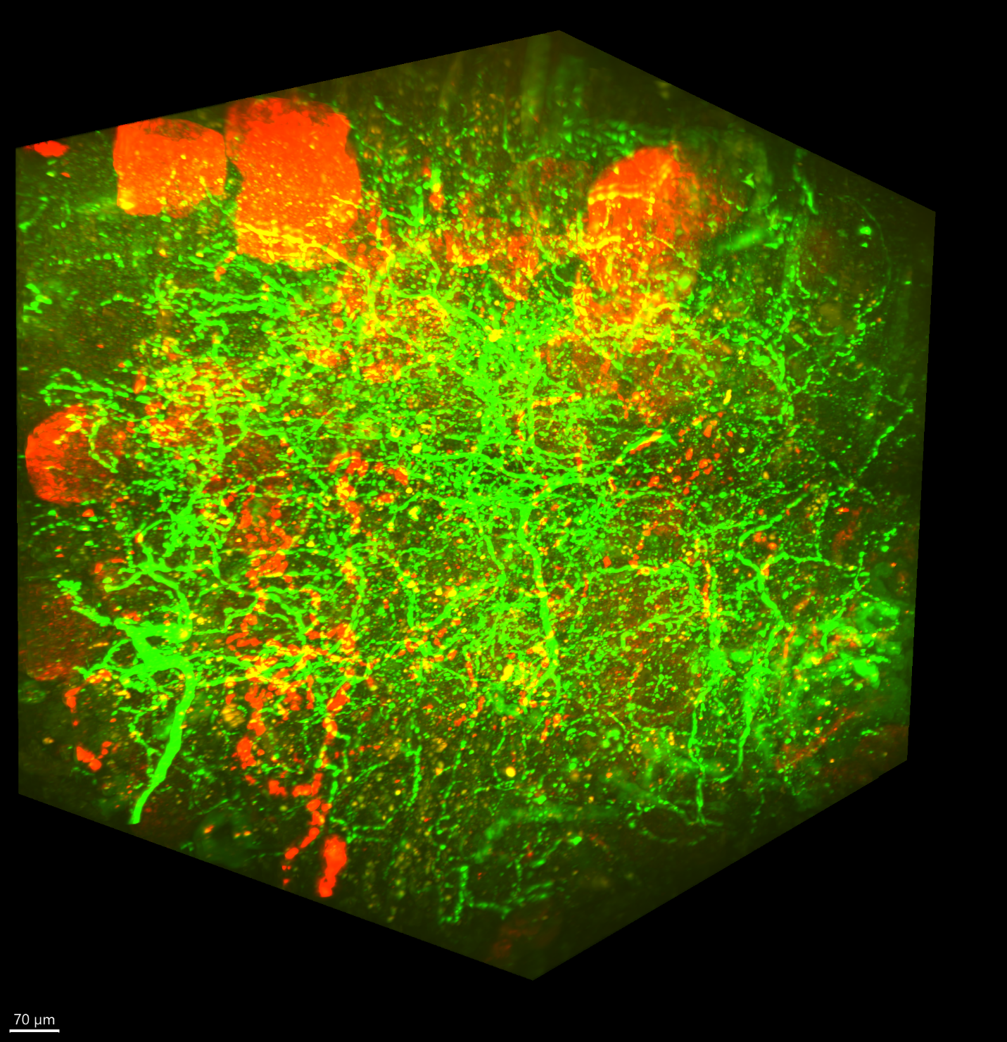

*Above: Lightsheet image of human kidney tissue. Glomeruli are stained in red and nerves are stained in green.*

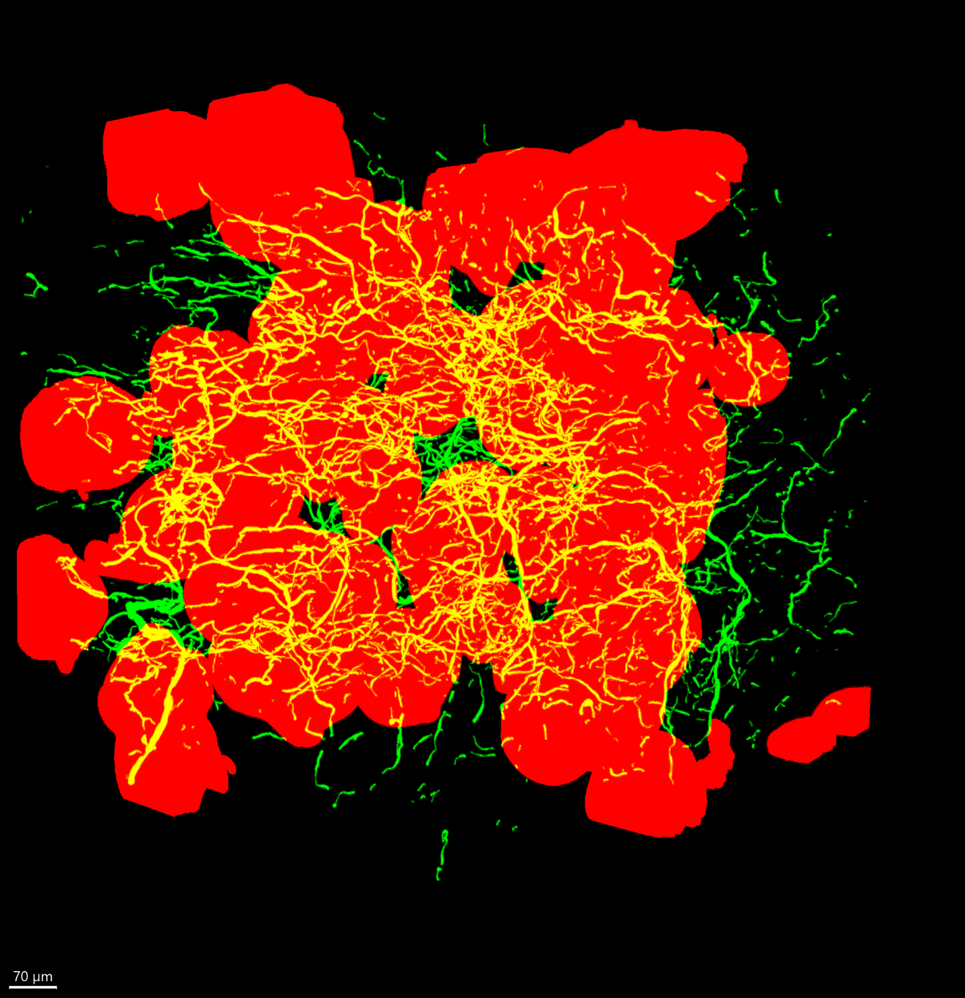

*Above: Binary segmentation of same kidney image, with glomeruli in red and nerves in green.*

With the above parameters in mind, we next call calculate_all() on our 3D network object.

|  |
| --- |
| from nettracer3d import nettracer  my_network = nettracer.Network_3D()  my_network.calculate_all('Gloms.tif', 'Nerves.tif', search = 10, diledge = 5, directory = 'dump', xy_scale = 0.914, z_scale = 0.496, GPU = True, down_factor = 5) |

At this point, the core algorithm has run, assigning values to all Network_3D properties. In addition, the properties themselves have been saved to my folder ‘dump’, which will allow me to initialize this same Network_3D object when running new scripts, without having to repeat the core algorithm. (See section on saving and loading Network_3D components).

**Saving and Loading Network_3D Properties Once Calculated**

Once we have run calculate_all(), my Network_3D object was assigned all its properties, however the variable was lost upon script termination. Luckily, calculate_all() saved all of its post-calculated properties to a specified directory. To rapidly recover my Network_3D object in a new script, I can call the assemble() method, documented below:

|  |
| --- |
| def assemble(self, directory = None, node_path = None, edge_path = None, search_region_path = None, network_path = None, node_centroids_path = None, node_identities_path = None, edge_centroids_path = None, scaling_path = None):  """  Can be called on a Network_3D object to load all properties simultaneously from a specified directory. It will look for files with the names specified in the property loading methods, in the active directory if none is specified.  Alternatively, for each property a filepath to any file may be passed to look there to load. This method is intended to be used together with the dump method to easily save and load the Network_3D objects once they had been calculated.  :param directory: (Optional - Val = None; String). The path to an intended directory to search for the all property files.  :param node_path: (Optional - Val = None; String). A path to any .tif to load into the nodes property.  :param edge_path: (Optional - Val = None; String). A path to any .tif to load into the edges property.  :param search_region_path: (Optional - Val = None; String). A path to any .tif to load into the search_region property.  :param network_path: (Optional - Val = None; String). A path to any .xlsx file to load into the network and network_lists properties.  :param node_centroids_path: (Optional - Val = None; String). A path to any .xlsx to load into the node_centroids property.  :param node_identities_path: (Optional - Val = None; String). A path to any .xlsx to load into the node_identities property.  :param edge_centroids_path: (Optional - Val = None; String). A path to any .xlsx to load into the edge_centroids property.  :param scaling_path: (Optional - Val = None; String). A path to any .txt to load into the xy_scale and z_scale properties.  """ |

In the ‘directory’ parameter of assemble(), I can pass a string file path to my directory containing my saved Network_3D properties. This will cause the program to check that directory for the saved files. By default, assemble() will always look for files with the same exact name that were assigned to them by calculate_all() (and the associated saving methods). Presuming I did not change the filenames, assemble() can be used to recover my Network_3D object with minimal syntax, as shown below:

|  |
| --- |
| from nettracer3d import nettracer as n3d  my_network = n3d.Network_3D()  my_network.assemble('dump') |

This will result in my Network_3D object having the same properties as the network I generated with calculate_all(). When working with Network_3D objects, it is therefore recommended to calculate their properties once, and thereafter simply call assemble() when working with the network. Note that although it is recommended to not change the filenames that were saved by calculate_all(), (with organization of different network outputs instead being denoted by naming the folder something specific), we can still load specific files by passing the corresponding parameter (such as node_path) in assemble() by passing the string filepath to any other file desired, presuming they are of the file format expected by that corresponding Network_3D property. To avoid calling assemble() when only loading specific properties, we can use each property’s corresponding load function, documented below:

|  |
| --- |
| def load_nodes(self, directory = None, file_path = None):  """  Can be called on a Network_3D object to load a tif into the nodes property as an ndarray. It will look for a file called 'labelled_nodes.tif' in the specified directory,  or the active directory if none has been selected. Alternatively, a file path to any tiff file may be passed to load into the nodes property.  :param directory: (Optional - Val = None; String). The path to an intended directory to search for the 'labelled_nodes.tif' file.  :param file_path: (Optional - Val = None; String). A path to any tif to load into the nodes property.  """      def load_edges(self, directory = None, file_path = None):  """  Can be called on a Network_3D object to load a tif into the edges property as an ndarray. It will look for a file called 'labelled_edges.tif' in the specified directory,  or the active directory if none has been selected. Alternatively, a file path to any tiff file may be passed to load into the edges property.  :param directory: (Optional - Val = None; String). The path to an intended directory to search for the 'labelled_edges.tif' file.  :param file_path: (Optional - Val = None; String). A path to any tif to load into the edges property.  """  def load_scaling(self, directory = None, file_path = None):  """  Can be called on a Network_3D object to load a .txt into the xy_scale and z_scale properties as floats. It will look for a file called 'voxel_scalings.txt' in the specified directory,  or the active directory if none has been selected. Alternatively, a file path to any txt file may be passed to load into the xy_scale/z_scale properties, however they must be formatted the same way as the 'voxel_scalings.txt' file.  :param directory: (Optional - Val = None; String). The path to an intended directory to search for the 'voxel_scalings.txt' file.  :param file_path: (Optional - Val = None; String). A path to any txt to load into the xy_scale/z_scale properties.  """  def load_network(self, directory = None, file_path = None):  """  Can be called on a Network_3D object to load a .xlsx into the network and network_lists properties as a networx graph and a list of lists, respecitvely. It will look for a file called 'output_network.xlsx' in the specified directory,  or the active directory if none has been selected. Alternatively, a file path to any .xlsx file may be passed to load into the network/network_lists properties, however they must be formatted the same way as the 'output_network.xlsx' file.  :param directory: (Optional - Val = None; String). The path to an intended directory to search for the 'output_network.xlsx' file.  :param file_path: (Optional - Val = None; String). A path to any .xlsx to load into the network/network_lists properties.  """  def load_search_region(self, directory = None, file_path = None):  """  Can be called on a Network_3D object to load a tif into the search_region property as an ndarray. It will look for a file called 'search_region.tif' in the specified directory,  or the active directory if none has been selected. Alternatively, a file path to any tiff file may be passed to load into the search_region property.  :param directory: (Optional - Val = None; String). The path to an intended directory to search for the 'search_region.tif' file.  :param file_path: (Optional - Val = None; String). A path to any tif to load into the search_region property.  """  def load_node_centroids(self, directory = None, file_path = None):  """  Can be called on a Network_3D object to load a .xlsx into the node_centroids property as a dictionary. It will look for a file called 'node_centroids.xlsx' in the specified directory,  or the active directory if none has been selected. Alternatively, a file path to any .xlsx file may be passed to load into the node_centroids property, however they must be formatted the same way as the 'node_centroids.xlsx' file.  :param directory: (Optional - Val = None; String). The path to an intended directory to search for the 'node_centroids.xlsx' file.  :param file_path: (Optional - Val = None; String). A path to any .xlsx to load into the node_centroids property.  """  def load_node_identities(self, directory = None, file_path = None):  """  Can be called on a Network_3D object to load a .xlsx into the node_identities property as a dictionary. It will look for a file called 'node_identities.xlsx' in the specified directory,  or the active directory if none has been selected. Alternatively, a file path to any .xlsx file may be passed to load into the node_identities property, however they must be formatted the same way as the 'node_identities.xlsx' file.  :param directory: (Optional - Val = None; String). The path to an intended directory to search for the 'node_identities.xlsx' file.  :param file_path: (Optional - Val = None; String). A path to any .xlsx to load into the node_identities property.  """  def load_edge_centroids(self, directory = None, file_path = None):  """  Can be called on a Network_3D object to load a .xlsx into the edge_centroids property as a dictionary. It will look for a file called 'edge_centroids.xlsx' in the specified directory,  or the active directory if none has been selected. Alternatively, a file path to any .xlsx file may be passed to load into the edge_centroids property, however they must be formatted the same way as the 'edge_centroids.xlsx' file.  :param directory: (Optional - Val = None; String). The path to an intended directory to search for the 'edge_centroids.xlsx' file.  :param file_path: (Optional - Val = None; String). A path to any .xlsx to load into the edge_centroids property.  """ |

Much like the assemble() function, each of these methods will search for a file with the name assigned by calculate_all() (and associated save methods) to set a Network_3D object property. The directory param is an optional string file path to some folder containing the desired file (otherwise the active directory will be checked), while the file_path param is a string file path to any file with any name, allowing files with other names to be manually loaded.

Working together with the assemble() method is the dump() method, documented below:

|  |
| --- |
| def dump(self, directory = None):  """  Can be called on a Network_3D object to save the all properties to hard mem. It will save to the active directory if none is specified.  :param directory: (Optional - Val = None; String). The path to an intended directory to save the properties to.  """ |

We can call dump() to save all Network_3D properties to the directory passed to the ‘directory’ parameter (or the active directory if nothing is passed. In instances where we have altered several properties of a Network_3D object, dump can be used to save them all with minimal syntax:

|  |
| --- |
| my_network.assemble('some_directory_with_saved_network_component')  my_network.nodes = new_nodes  my_network.edges = new_edges  my_network.dump('new_directory_path') |

If we do not want to save everything at once, properties can also be saved to disk one at a time using their corresponding save method:

|  |
| --- |
| def save_nodes(self, directory = None):  """  Can be called on a Network_3D object to save the nodes property to hard mem as a tif. It will save to the active directory if none is specified.  :param directory: (Optional - Val = None; String). The path to an indended directory to save the nodes to.  """  def save_edges(self, directory = None):  """  Can be called on a Network_3D object to save the edges property to hard mem as a tif. It will save to the active directory if none is specified.  :param directory: (Optional - Val = None; String). The path to an indended directory to save the edges to.  """  def save_scaling(self, directory = None):  """  Can be called on a Network_3D object to save the xy_scale and z_scale properties to hard mem as a .txt. It will save to the active directory if none is specified.  :param directory: (Optional - Val = None; String). The path to an indended directory to save the scalings to.  """  def save_node_centroids(self, directory = None):  """  Can be called on a Network_3D object to save the node centroids properties to hard mem as a .xlsx file. It will save to the active directory if none is specified.  :param directory: (Optional - Val = None; String). The path to an indended directory to save the centroids to.  """  def save_edge_centroids(self, directory = None):  """  Can be called on a Network_3D object to save the edge centroids properties to hard mem as a .xlsx file. It will save to the active directory if none is specified.  :param directory: (Optional - Val = None; String). The path to an indended directory to save the centroids to.  """  def save_search_region(self, directory = None):  """  Can be called on a Network_3D object to save the search_region property to hard mem as a tif. It will save to the active directory if none is specified.  :param directory: (Optional - Val = None; String). The path to an indended directory to save the search_region to.  """  def save_network(self, directory = None):  """  Can be called on a Network_3D object to save the network_lists property to hard mem as a .xlsx. It will save to the active directory if none is specified.  :param directory: (Optional - Val = None; String). The path to an intended directory to save the network lists to.  """  def save_node_identities(self, directory = None):  """  Can be called on a Network_3D object to save the node_identities property to hard mem as a .xlsx. It will save to the active directory if none is specified.  :param directory: (Optional - Val = None; String). The path to an intended directory to save the node_identities to.  """ |

Like always, these properties will save to the active directory if a string file path is not passed to the directory param.

All Network_3D properties have functional getters/setters, meaning during any runtime instance we can isolate properties into singular variables like so:

|  |
| --- |
| my_nodes = my_network.nodes  my_network_graph = my_network.network  my_xy_scale = my_network.xy_scale  my_z_scale = my_network.z_scale  my_network_lists = my_network.network_lists  my_edges = my_network.edges  my_search_region = my_network.search_region  my_node_identities = my_network.node_identities  my_node_centroids = my_network.node_centroids  my_edge_centroids = my_network.edge_centroids |

Expectedly, we can simply call a property getter (such as: my_network.nodes) as a singular variable itself, which enables us to perform variable-specific analysis on properties. Likewise, we can set all properties from any external variables, provided they are of the format expected by some property, like so:

|  |
| --- |
| my_network.nodes = some_numpy_array  my_network.network = some_networkx_graph #Note that setting the network auto-updates the associated network_lists property  my_network.xy_scale = 0.8  my_network.z_scale = 0.6  my_network.network_lists = some_list #Updating the network_lists property likewise updates the network property, but working with this property is usually not as necessary.  my_network.edges = some_second_numpy_array  my_network.search_region = some_third_numpy_array  my_network.node_identities = some_dictionary  my_network.node_centroids = some_second_dictionary  my_network.edge_centroids = some_third_dictionary |

As the numpy array-containing properties of Network_3D objects may take up a lot of RAM when loaded together, we are also able to delete these larger properties with delete functions that set their internal attribute to None. This can enable us, when needed, to remove larger components of the Network_3D object that may not be necessary for some particular analysis.

|  |
| --- |
| del my_network.nodes  del my_network.edges  del my_network.search_region |

Finally, merely declaring new variables pointing to the same Network_3D object may result in them sharing their internal properties, meaning the new Network_3D copy cannot be altered independent of the first Network_3D object. To address this, please use the copy() method to create a deep copy of the object that is totally independent of the original:

|  |
| --- |
| def copy(self):  """  Copies a Network_3D object so the new object can be freely editted independent of a previous one  :return: a deep copy of a Network_3D object  """ |

With copy() implementation looking like:

|  |
| --- |
| my_network = n3d.Network_3D()  my_network.assemble('dump') #Presuming this is where calculated outputs were stored  new_network = my_network.copy()  new_network.downsample(5)  print(new_network.nodes.shape) #Altered copy will print a numpy shape that is 5 times smaller in all three dimensions  print(my_network.nodes.shape) #Original shape will remain the same |

While it is most often recommended to use calculate_all() to assign all properties of a Network_3D object at once, its components can be computed in a piece-meal style, one property at a time, which can allow for greater flexibility, especially regarding parameter tuning. This can be completed in totality using the following seven methods documented below:

|  |
| --- |
| def label_nodes(self):  """  Method to assign a unique numerical label to all discrete objects contained in the ndarray in the nodes property.  Expects the nodes property to be set to (presumably) a binary ndarray. Sets the nodes property.  """  def merge_nodes(self, addn_nodes_name, label_nodes = True):  """  Merges the self._nodes attribute with alternate labelled node images. The alternate nodes can be inputted as a string for a filepath to a tif,  or as a directory address containing only tif images, which will merge the _nodes attribute with all tifs in the folder. The _node_identities attribute  meanwhile will keep track of which labels in the merged array refer to which objects, letting user track multiple seperate biological objects  in a single network. Note that an optional param, 'label_nodes' is set to 'True' by default. This will cause the program to label any intended  additional nodes based on seperation in the image. If your nodes a prelabelled, please input the argument 'label_nodes = False'  :param addn_nodes_name: (Mandatory; String). Path to either a tif file or a directory containing only additional node files.  :param label_nodes: (Optional - Val = True; Boolean). Will label all discrete objects in each node file being merged if True. If False, will not label.  """  def calculate_search_region(self, search_region_size, GPU = True, fast_dil = False):  """  Method to obtain the search region that will be used to assign connectivity between nodes. May be skipped if nodes do not want to search and only want to look for their  connections in their immediate overlap. Expects the nodes property to be set. Sets the search_region property.  :param search_region_size: (Mandatory; int). Amount nodes should expand outward to search for connections. Note this value corresponds one-to-one with voxels unless voxel_scaling has been set, in which case it will correspond to whatever value the nodes array is measured in (microns, for example).  :param GPU: (Optional - Val = True; boolean). Will use GPU if avaialble (including necessary downsampling for GPU RAM). Set to False to use CPU with no downsample.  :param fast_dil: (Optional - Val = False, boolean) - A boolean that when True will utilize faster cube dilation but when false will use slower spheroid dilation.  """  def calculate_edges(self, binary_edges, diledge = None, inners = True, hash_inner_edges = True, search = None, remove_edgetrunk = 0, GPU = True, fast_dil = False):  """  Method to calculate the edges that are used to directly connect nodes. May be done with or without the search region, however using search_region is recommended.  The search_region property must be set to use the search region, otherwise the nodes property must be set. Sets the edges property  :param binary_edges: (Mandatory; String or ndarray). Filepath to a binary tif containing segmented edges, or a numpy array of the same.  :param diledge: (Optional - Val = None; int). Amount to dilate edges, to account for imaging and segmentation artifacts that have brokenup edges. Any edge masks that are within half the value of the 'diledge' param will become connected. Ideally edges should not have gaps,  so some amount of dilation is recommended if there are any, but not so much to create overconnectivity. This is a value that needs to be tuned by the user.  :param inners: (Optional - Val = True; boolean). Will use inner edges if True, will not if False. Inner edges are parts of the edge mask that exist within search regions. If search regions overlap,  any edges that exist within the overlap will only assert connectivity if 'inners' is True.  :param hash_inner_edges: (Optional - Val = True; boolean). If False, all search regions that contain an edge object connecting multiple nodes will be assigned as connected.  If True, an extra processing step is used to sort the correct connectivity amongst these search_regions. Can only be computed when search_regions property is set.  :param search: (Optional - Val = None; int). Amount for nodes to search for connections, assuming the search_regions are not being used. Assigning a value to this param will utilize the secondary algorithm and not the search_regions.  :param remove_edgetrunk: (Optional - Val = 0; int). Amount of times to remove the 'Trunk' from the edges. A trunk in this case is the largest (by vol) edge object remaining after nodes have broken up the edges.  Any 'Trunks' removed will be absent for connection calculations.  :param GPU: (Optional - Val = True; boolean). Will use GPU (if available) for the hash_inner_edges step if True, if False will use CPU. Note that the speed is comparable either way.  :param fast_dil: (Optional - Val = False, boolean) - A boolean that when True will utilize faster cube dilation but when false will use slower spheroid dilation.  """  def calculate_network(self, search = None, ignore_search_region = False):  """  Method to calculate the network from the labelled nodes and edge properties, once they have been calculated. Network connections are assigned based on node overlap along  the same edge of some particular label. Sets the network and network_lists properties.  :param search: (Optional - Val = None; Int). Amount for nodes to search for connections if not using the search_regions to find connections.  :param ignore_search_region: (Optional - Val = False; Boolean). If False, will use primary algorithm (with search_regions property) to find connections. If True, will use secondary algorithm (with nodes) to find connections.  """  def calculate_node_centroids(self, down_factor = None):  """  Method to obtain node centroids. Expects _nodes property to be set. Downsampling is optional to speed up the process. Centroids will be scaled to 'true' undownsampled location when downsampling is used.  Sets the _node_centroids attribute.  :param down_factor: (Optional - Val = None; int). Optional factor to downsample nodes during centroid calculation to increase speed.  """  def calculate_edge_centroids(self, down_factor = None):  """  Method to obtain edge centroids. Expects _edges property to be set. Downsampling is optional to speed up the process. Centroids will be scaled to 'true' undownsampled location when downsampling is used.  Sets the _edge_centroids attribute.  :param down_factor: (Optional - Val = None; int). Optional factor to downsample edges during centroid calculation to increase speed.  """ |

Using piece-meal assembly of the Network_3D object’s properties means we can calculate each component as needed, and at our own pace. Note that several of these methods will only run once certain other Network_3D properties to have already been assigned. For this explanation, we will be using a separate sample of human kidney tissue to create neural networks containing both glomeruli and collecting ducts.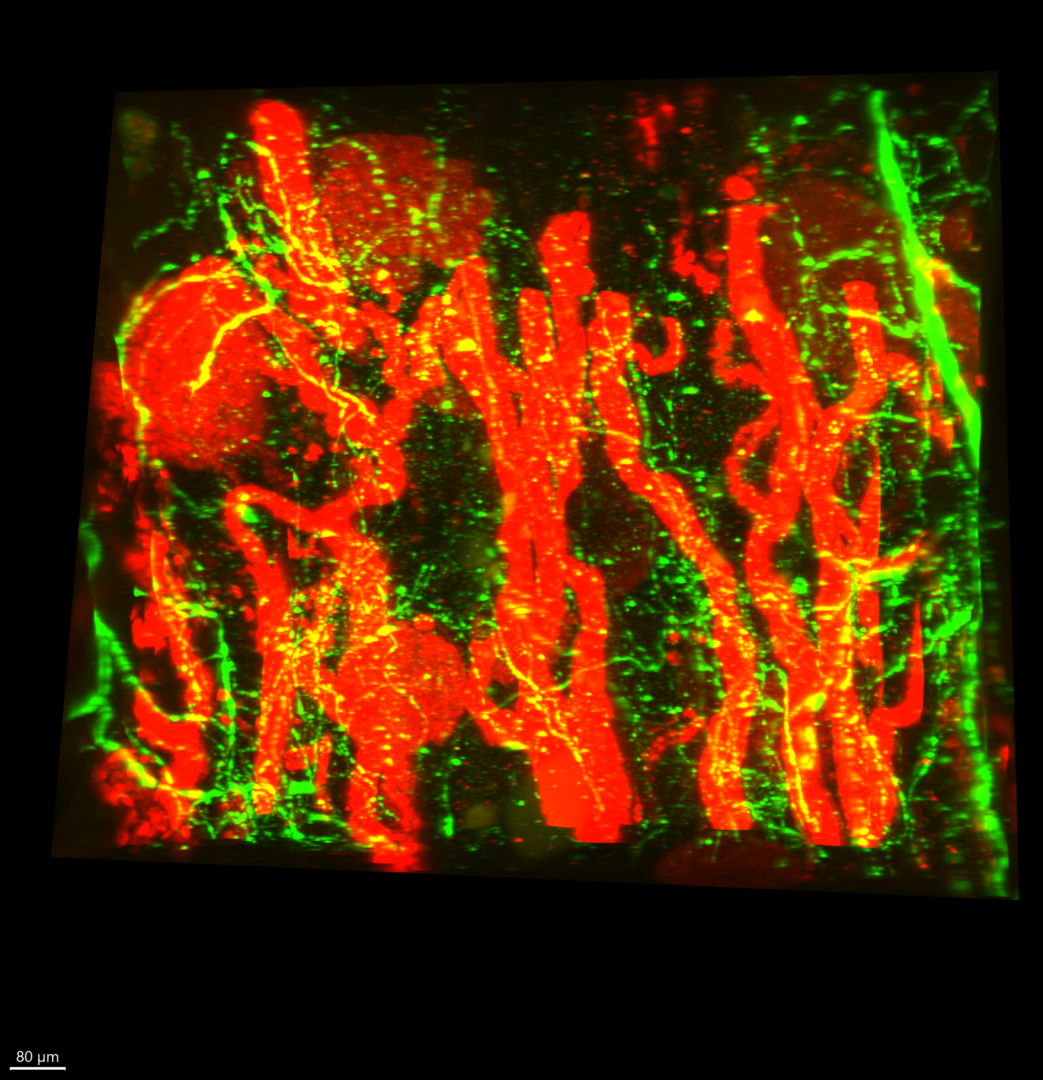

*Above: Lightsheet image of human kidney with stained glomeruli (red) and collecting ducts (also red), and nerves (green).*

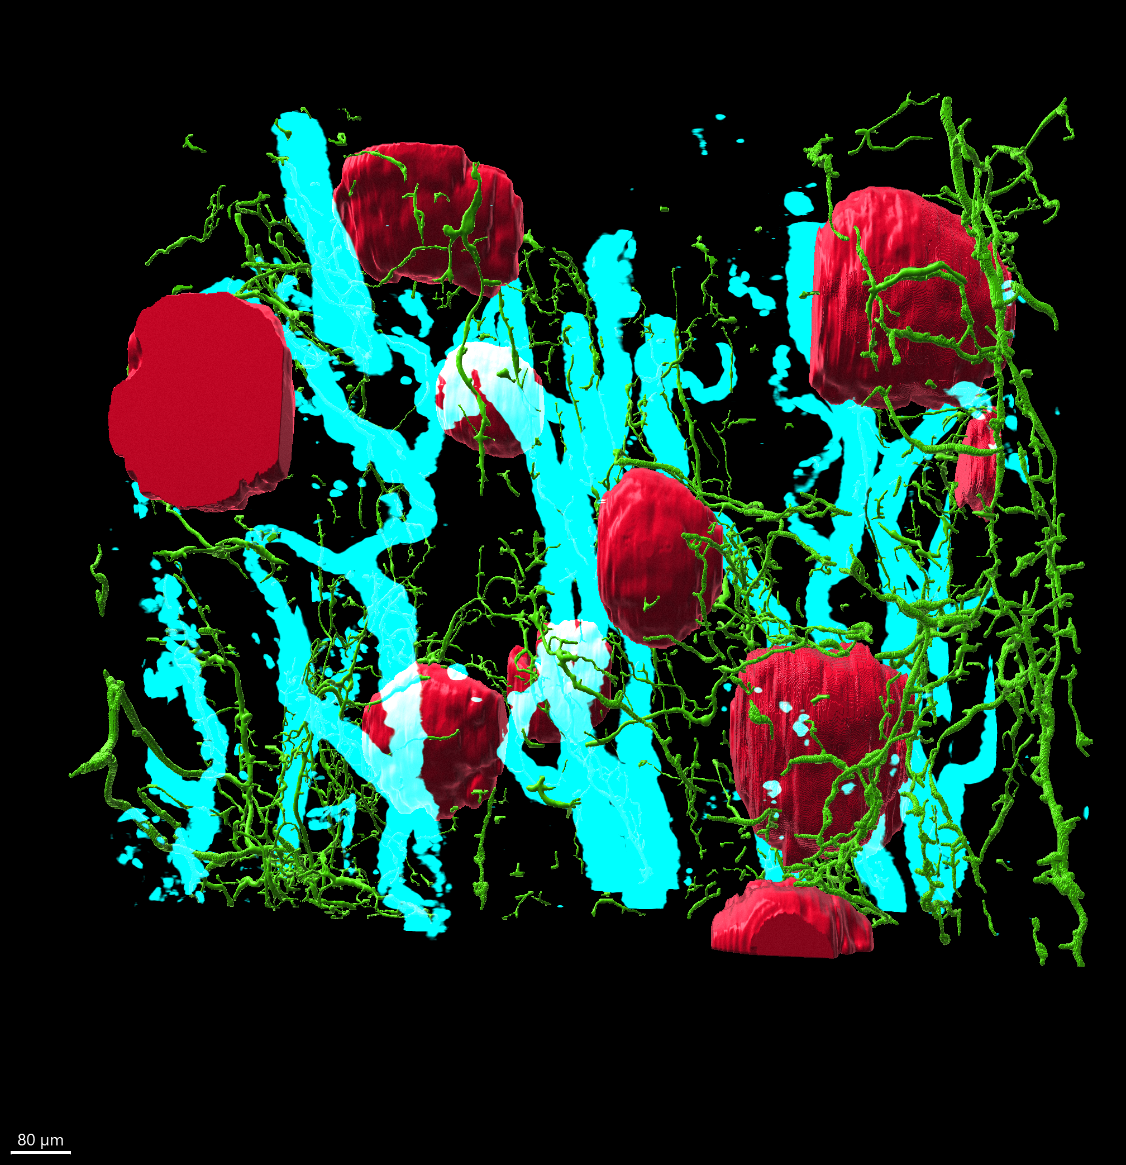

*Above: Same lightsheet image of human kidney with segmented glomeruli and nerves in red and green, respectively, and ducts shown in cyan.*

An example implementation is shown below. First we have a demonstration of how to calculate the network with the calculate_all() command, then afterwards, with piecemeal assembly.

|  |
| --- |
| from nettracer3d import nettracer as n3d  my_network = n3d.Network_3D()  my_network.calculate_all('Gloms_2.tif', 'Nerves_2.tif', search = 10, diledge = 5, directory = 'identity_dump', xy_scale = 0.955, z_scale = 0.467, GPU = True, down_factor = 5, other_nodes = 'Ducts_2.tif')  del my_network #The above all-in-one method will yield the same result as the piecemeal implementation shown below. I am deleting my Network_3D object so I can recreate it below:  my_network = n3d.Network_3D()  my_network.xy_scale = 0.955  my_network.z_scale = 0.467  my_network.label_nodes('Gloms_2.tif')  my_network.merge_nodes('Ducts_2.tif', label_nodes = True)  my_network.calculate_search_region(10)  my_network.calculate_edges('Nerves_2.tif', diledge = 5)  my_network.calculate_network()  my_network.calculate_node_centroids(5)  my_network.calculate_edge_centroids(5)  my_network.dump('identity_dump') |

Note that piece-meal assembly (of some extent) is the ONLY way to introduced prelabelled edges (for example, by the label_branches() function) into network calculation. Instead of calling calculate_edges(), use load_edges() to assign the edges as the prelabelled .tif, before calling calculate_network() and calculate_edge_centroids() (also assuming node-related properties have been calculated already). Finally, these methods can be used in whatever order after calculate_all(), to evaluate how different approaches to each step alter the output.

**Visualizing the Network Once Generated**

Once calculated, there are several methods that allow us to view the network graph of a Network_3D’s network property using NetworkX and matplotlib. The simplest way to accomplish this is with the show_network() method:

|  |
| --- |
| def show_network(self, geometric = False):  """  Shows the network property as a simplistic graph, and some basic stats. Does not support viewing edge weights.  :param geometric: (Optional - Val = False; boolean). If False, node placement in the graph will be based on connections. If True, nodes  will be placed in their actual spatial location (from the original node segmentation) along the XY plane, using node_centroids.  The node size will then represent the nodes Z location, with smaller nodes representing a larger Z value. If False, nodes will be placed randomly.  :param directory: (Optional – Val = None; string). An optional string path to a directory to save the network plot image to. If not set, nothing will be saved.  """ |

This will show a simple undirected network of just the nodes and their connections. This will typically be accomplished like so:

|  |
| --- |
| from nettracer3d import nettracer as n3d  my_network = n3d.Network_3D()  my_network.assemble('dump') #presuming I saved a previously calculated network to the 'dump' directory.  my_network.show_network() |

This method features the optional parameter ‘geometric’, a True/False boolean that is False by default. When False, nodes will be placed in random locations. By passing True to ‘geometric’, the location of nodes in the network graph will directly reflect their actual spatial locations in the original segmented image, with the X/Y value being one-to-one with the original image, while the Z value is represented by the size of the node (with larger nodes representing a smaller Z value, with the idea being they are ‘closer’ in the field of view). As expected, this param requires node_centroids to be computed to function. All additional network visualization methods described below feature the ‘geometric’ param. In addition to showing the network, these network methods also print a few stats, such as the number of nodes, the number of edges (including duplicate edges), and the ‘average degree connectivity’ (being a dictionary where each key is the degree, or number of connections, of some amount of nodes in the network, while the value is the average degree of nodes that are immediately connected to the nodes of the aforementioned key degree).

We may be interested in community detection of elements of the network. Community detection utilizes a mathematical algorithm to group nodes into ‘communities’, that contain greater connectivity amongst themselves than between separate communities. As one might expect, communities in networks typically operate semi-autonomously of the larger network and can provide insights into network function. We have two options for viewing a network graph and its communities, where nodes are color-coded by the community they are a part of:

|  |
| --- |
| def show_communities(self, geometric = False):  """  Shows the network property, and some basic stats, as a graph where nodes are labelled by colors representing the community they belong to as determined by a label propogation algorithm. Does not support viewing edge weights.  :param geoemtric: (Optional - Val = False; boolean). If False, node placement in the graph will be based on connections. If True, nodes  will be placed in their actual spatial location (from the original node segmentation) along the XY plane, using node_centroids.  The node size will then represent the nodes Z location, with smaller nodes representing a larger Z value. If False, nodes will be placed randomly.  :param directory: (Optional – Val = None; string). An optional string path to a directory to save the network plot image to. If not set, nothing will be saved.  """  def show_communities_louvain(self, geometric = False):  """  Shows the network property as a graph, and some basic stats, where nodes are labelled by colors representing the community they belong to as determined by a louvain algorithm. Supports viewing edge weights.  :param geoemtric: (Optional - Val = False; boolean). If False, node placement in the graph will be based on connections. If True, nodes  will be placed in their actual spatial location (from the original node segmentation) along the XY plane, using node_centroids.  The node size will then represent the nodes Z location, with smaller nodes representing a larger Z value. If False, nodes will be placed randomly.  :param directory: (Optional – Val = None; string). An optional string path to a directory to save the network plot image to. If not set, nothing will be saved.  """ |

The two methods above provide two separate community detection algorithm. The first algorithm utilizes ‘label propogation’ and is slightly faster while the second utilizes ‘louvain detection’. Both algorithms have slightly different results that may be ideal depending on the circumstances. Please note that show_communities_louvain() is the ONLY network visualization method as of now that will actually show weighted edges in the network. These methods will be called exactly like show_network():

|  |
| --- |
| my_network.show_communities()  my_network.show_communities_louvain(geoemetric = True) #Using the optional 'geometric' param |

This code will yield the following output:

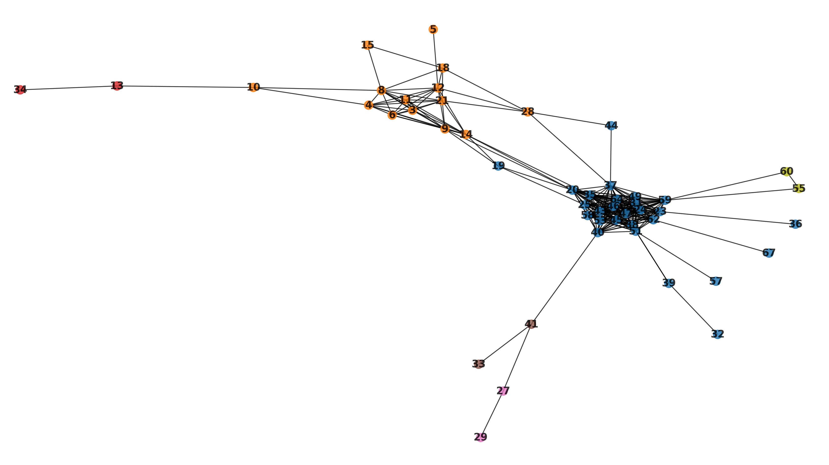

*Above: Output from my_network.show_communities(). We can observe how the algorithm has found two major communities (colored orange/blue). Without setting ‘geometric’ to True, we can see how the layout is organized in a way that is optimal for viewing community separation.*

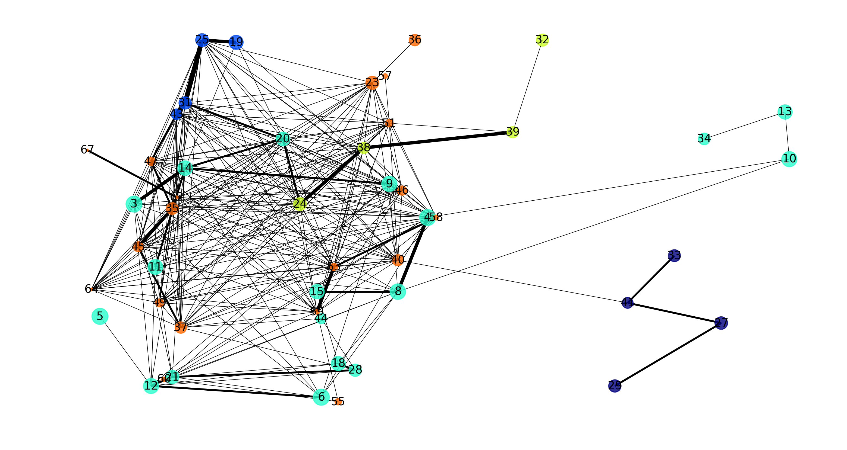

*Above: Output from the my_network.show_communities_louvain(geoemetric = True) command above.* *By setting ‘geometric’ to True, we instead see the spatial arrangement of the nodes, demonstrating that most of the nodes in this network are localized on the left side of the image, with the (previously orange) cyan community near the front of the Z-stack, and the (previously blue) orange community largely positioned in the back of the Z-stack.*

Both community-visualization additionally print the network’s ‘modularity’ statistic. In short, modularity is a measurement of how ‘statistically surprising’ a network’s community structure is, with a value of 0 being closer to a result expected from some hypothetical random network (which scarcely features community structure), while 1 represents a strong community structure highly unlikely from a random network.

For the purposes of analysis, we can call the following methods to obtain this modularity stastistic without bothering to show the graph (again with label propagation or Louvain as options):

|  |
| --- |
| def modularity(self, solo_mod = False):  """  Shows some basic stats of the network, including modularity (essentially strength of community structure), using a label propogation algorithm that does not consider edge weights.  :param solo_mod: (Optional - Val = False; boolean). If True, will return a singular modularity for the network, taking into  account all disconnected components as pieces of a network. If False, will return the modularity of each singular disconnected component of the network with the number of nodes in the component as a key  and the modularity of the component as a value.  :returns: A dictionary containing the modularity for each disconnected component in the network, key-indexed by that component's node count, or a single modularity value accounting for all disconnected components of the network if the solo_mod param is True.  """  def louvain_modularity(self, solo_mod = False):  """  Shows some basic stats of the network, including modularity (essentially strength of community structure), using a louvain algorithm that accounts for edge weights.  :param solo_mod: (Optional - Val = False; boolean). If True, will return a singular modularity for the network, taking into  account all disconnected components as pieces of a network. If False, will return the modularity of each singular disconnected component of the network with the number of nodes in the component as a key  and the modularity of the component as a value.  :returns: A dictionary containing the modularity for each disconnected component in the network, key-indexed by that component's node count, or a single modularity value accounting for all disconnected components of the network if the solo_mod param is True.  """ |

The parameter solo_mod is a True/False boolean. When True, the network will return a single modularity value for the entire network, even when the network consists of multiple disconnected components. In this case, the disconnected components will be treated as independent communities and cause the modularity score to increase overall. When set to the default value of False, instead a dictionary will be returned where each key is the number of nodes in a given disconnected network component, and the value is that component’s modularity. We can accomplish this like so:

|  |
| --- |
| my_mod = my_network.modularity(solo_mod = True) #We can now use the 'my_mod' variable to do some calculation with the modularity.  my_louvain_mod = my_network.louvain_modularity() #By passing now params, I by default obtain a dictionary of modularities for each disconnected component. |

If my network consists of nodes that each represent a different kind of true biological (or similar) object, I can differentiate nodes during visualization with the show_identity_network() method:

|  |
| --- |
| def show_identity_network(self, geometric = False):  """  Shows the network property, and some basic stats, as a graph where nodes are labelled by colors representing the identity of the node as detailed in the node_identities property. Does not support viewing edge weights.  :param geoemtric: (Optional - Val = False; boolean). If False, node placement in the graph will be based on connections. If True, nodes  will be placed in their actual spatial location (from the original node segmentation) along the XY plane, using node_centroids.  The node size will then represent the nodes Z location, with smaller nodes representing a larger Z value. If False, nodes will be placed randomly.  :param directory: (Optional – Val = None; string). An optional string path to a directory to save the network plot image to. If not set, nothing will be saved.  """ |

Going back to our network containing both glomeruli and ducts, in the graph displayed by show_identity_network(), each node is colored based on its identity as indexed in the node_identities property, with an accompanying legend.

|  |
| --- |
| from nettracer3d import nettracer  my_network = nettracer.Network_3D()  my_network.calculate_all('Gloms_2.tif', 'Nerves_2.tif', search = 10, diledge = 5, directory = 'identity_dump', xy_scale = 0.955, z_scale = 0.467, GPU = True, down_factor = 5, other_nodes = 'Ducts_2.tif')  my_network.show_identity_network() |

|  |
| --- |
|  |

*Above: The output from show_identity_network() showing connectivity between collecting ducts and glomeruli. Note that connections before and after a node are not necessarily resulting from the same ‘edge object’.*

This represents all the current methods for directly displaying and quantifying networks directly from the ‘network’ property, but as NetTracer3D generates a NetworkX graph object, all sorts of similar analysis can be applied by using NetworkX functions:

|  |
| --- |
| from nettracer3d import nettracer as n3d  import networkx as nx #Import networkx  my_network = n3d.Network_3D()  my_network.assemble('dump')  G = my_network.network #Assign the network property from my Network_3D object to a var  shortest_path = nx.shortest_path(G, source=1, target = 5) #For example, I can call this networkx function that returns a list of nodes that represent the shortest node-to-node path from my node ID'd as 1 to my node ID'd as 5. |

Beyond the functions that have been programmed into NetTracer3D directly, these Network_3D objects are good starting points for analysis offered by tools such as NetworkX (documentation: <https://networkx.org/documentation/stable/reference/index.html>).

Unique to Network_3D objects is the ability to unify such mathematical network analysis to the real 3D morphology of a biological specimen. For example, NetTracer3D offers the ability to draw informative network overlays that can be used to visualize the network in 3D space, especially in-tandem with powerful 3D visualization software like Imaris. Three such methods are shown below:

|  |
| --- |
| def draw_network(self, directory = None, down_factor = None):  """  Method that draws the 3D network lattice for a Network_3D object, to be used as an overlay for viewing network connections.  Lattice will be saved as a .tif to the active directory if none is specified. Will used the node_centroids property for faster computation, unless passed the down_factor param.  :param directory: (Optional - Val = None; string). Path to a directory to save the network lattice to.  :param down_factor: (Optional - Val = None; int). Factor to downsample nodes by for calculating centroids. The node_centroids property will be used if this value is not set. If there are no node_centroids, this value must be set (to 1 or higher).  """  def draw_node_indices(self, directory = None, down_factor = None):  """  Method that draws the numerical IDs for nodes in a Network_3D object, to be used as an overlay for viewing node IDs.  IDs will be saved as a .tif to the active directory if none is specified. Will used the node_centroids property for faster computation, unless passed the down_factor param.  :param directory: (Optional - Val = None; string). Path to a directory to save the node_indicies to.  :param down_factor: (Optional - Val = None; int). Factor to downsample nodes by for calculating centroids. The node_centroids property will be used if this value is not set. If there are no node_centroids, this value must be set (to 1 or higher).  """  def draw_edge_indices(self, directory = None, down_factor = None):  """  Method that draws the numerical IDs for edges in a Network_3D object, to be used as an overlay for viewing edge IDs.  IDs will be saved as a .tif to the active directory if none is specified. Will used the edge_centroids property for faster computation, unless passed the down_factor param.  :param directory: (Optional - Val = None; string). Path to a directory to save the edge indices to.  :param down_factor: (Optional - Val = None; int). Factor to downsample edges by for calculating centroids. The edge_centroids property will be used if this value is not set. If there are no edgde_centroids, this value must be set (to 1 or higher).  """ |

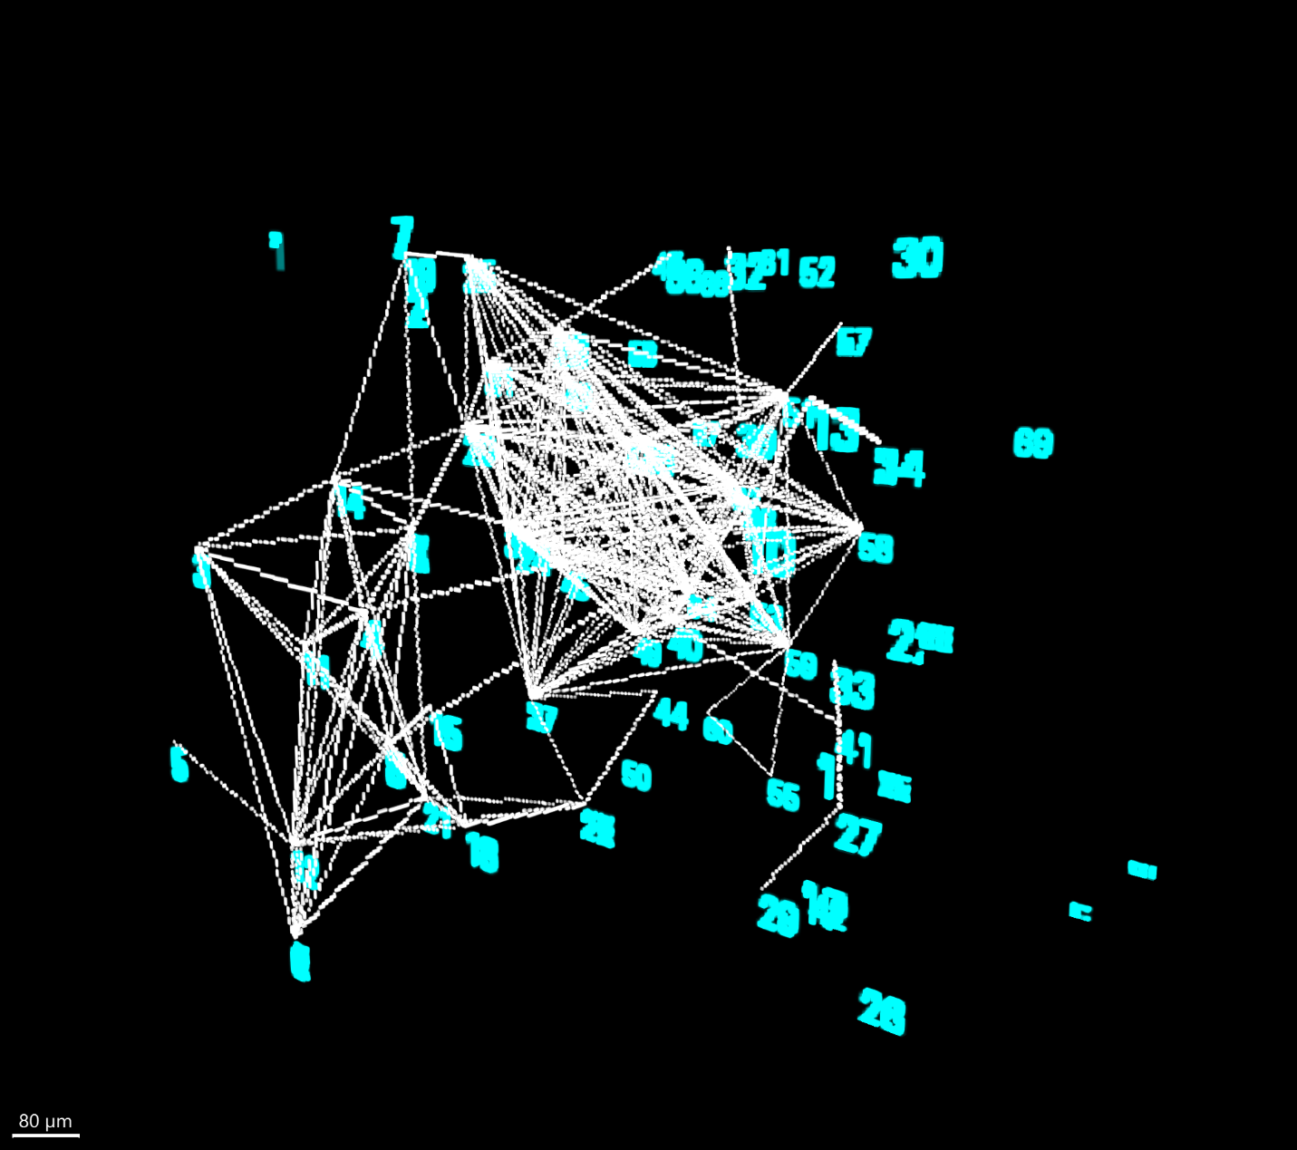

*Above: Both the drawn network lattice from draw_network() in white and the blue node index overlay from draw_node_indices() shown in 3D.*

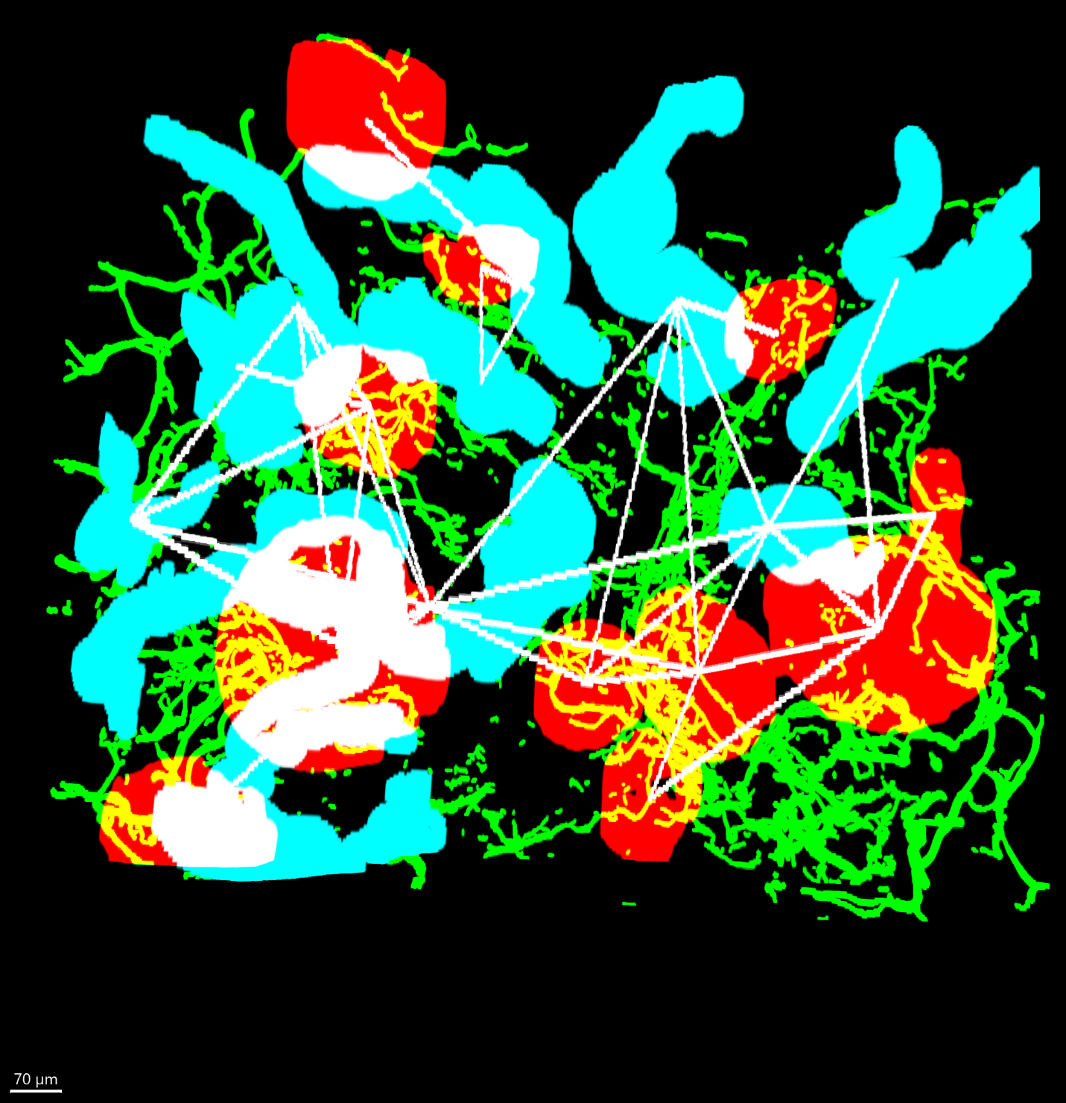

*Above: Although the specific code to generate this image was not shown, this is what we obtain by calling draw_network() on my other Network_3D object that is associated with the collecting duct/glomerulus image. Now, we can see where nerves connect glomeruli to collecting ducts, as well as other glomeruli. (Glomeruli are red, nerves are green, ducts are cyan, connections are white).*

Calling any of these three methods on a Network_3D object will create a tif file overlay. Method draw_network() will create straight white-lines between any connected nodes from the original image, while draw_node_indices() and draw_edge_indices() will draw into 3D space the index of that corresponding node/edge, which will allow us to easily relate objects in the image arrays to the data stored in the Network_3D object. These methods have two params, with directory simply being a string file path to a desired output directory (otherwise the active directory will be utilized), while down_factor is an integer that the array will be downsampled by in each of its dimensions. Although these methods can utilize pre-calculated centroid properties and therefore will run fast on a complete Network_3D object, some amount of online downsample may be ideal, as it causes the elements of the drawn overlay themselves to be enlarged which can lead to better visualization. Although the output will be downsampled and not directly fit over the original image, the rescale() method can be called to return the downsampled arrays to the proper size, retaining their element-enlargement.

While NetTracer3D is not designed as an image visualization tool, it does feature a rudimentary array visualization method using plotly that can be used to peek at Network_3D objects as a 3D isosurface. For a Network_3D object, we can visualize edge and node segmentations alongside additional binary (or just background = 0) images using the show_3D() method:

|  |
| --- |
| def show_3D(self, other_arrays = None, down_factor = 1):  """  Allows the Network_3D object to be visualized in 3D using plotly. By default, this will show the nodes and edges properties. All arrays involved will be made binary.  Note that nettracer3D is not primarily a 3D visualization tool, so the funcionality of this method is limited, and additionally it should really only be run on downsampled data.  :param other_arrays: (Optional - Val = None; string). A filepath to additional .tif files (or a directory containing only .tif files) to show alongside the Network_3D object, for example a node_indicies or network_lattice overlay.  :param down_factor: (Optional - Val = 1; int). A downsampling factor to speed up showing the 3D display and improve processing. Note that ALL arrays being shown will be subject  to this downsample factor. If you have files to be shown alongside the Network_3D object that were ALREADY downsampled, make sure their shapes are all mathematically similar.  If arrays are sized to different shapes while show_3D() is being called, there may be unusual results.  """ |

By default, this method requires the nodes property to be set, and will visualize the nodes and edges as isosurfaces if available. This method features an ‘other_arrays’ param which takes a string of either a file path to an additional .tif file, or a file path to a folder containing ONLY additional .tif files wanting to be displayed. All additional .tif files will then be rendered overtop the nodes/edges. Note that if nodes/edges are not wanting to be displayed, the visualize_3D() function can be used instead. Additionally, an optional downsample factor can be passed to make data visualization easier. Any additional arrays specified by the ‘other_arrays’ param will likewise be resampled to match the (now downsampled) nodes display but only if both arrays have (mathematically) similar 3D shapes,

|  |
| --- |
| my_network = n3d.Network_3D()  my_network.assemble('dump') #Presuming this is where calculated outputs were stored  my_network.show_3D(down_factor = 5) |

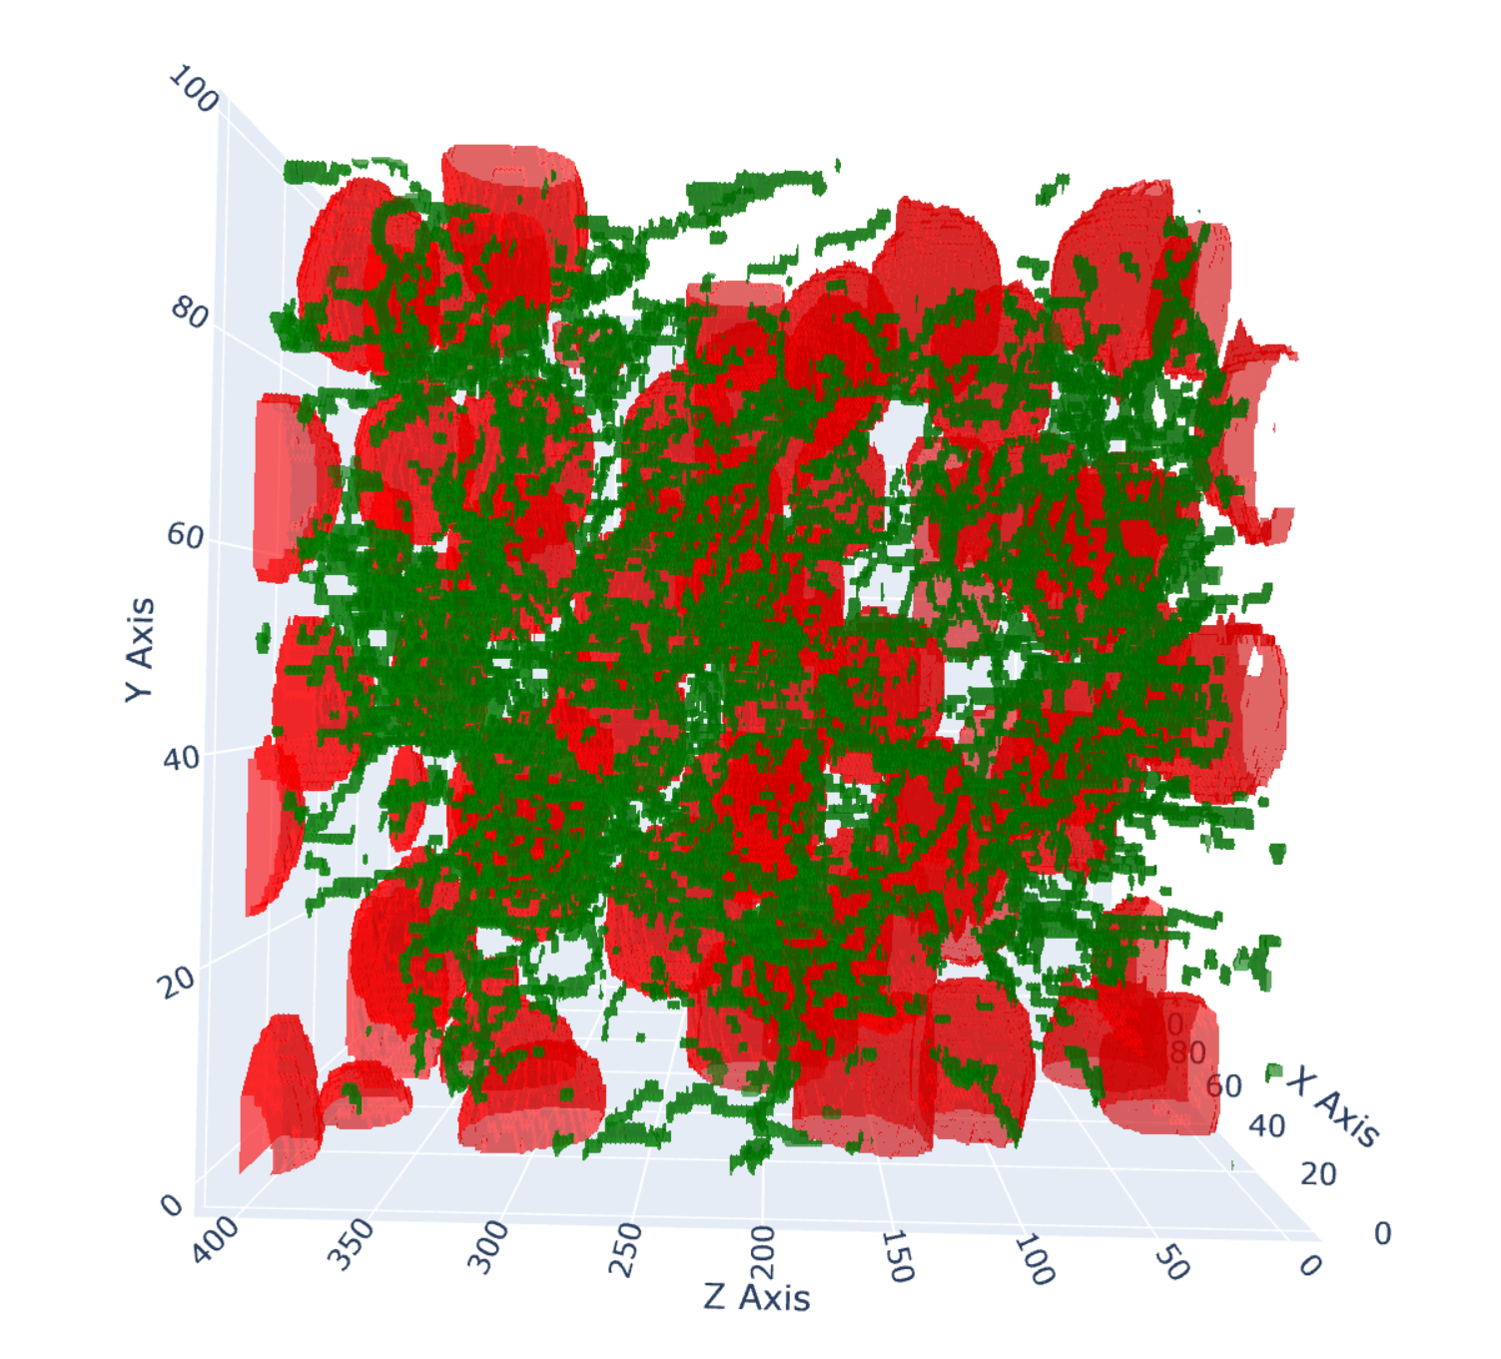

*Above: Red glomerulus segmentation and green nerve segmentation from the image associated with the my_network variable, as rendered by the show_3D() implementation above.*

Note that a Network_3D object can also be predownsampled with the downsample() method, then visualized while passing no down_factor. For larger arrays, some level of downsample is likely needed to enable visualization.

One good use of this method is to visualize nodes and their connectivity through the output of draw_network(). For this purpose, I would recommend downsampling draw_network() during its execution rather than afterwards, as downsampling in post may cause the thin lines to be disrupted. For example:

|  |
| --- |
| my_network = n3d.Network_3D()  my_network.assemble('dump') #Presuming this is where calculated outputs were stored  my_network.draw_network(directory = 'other_folder', down_factor = 5) #This will create a small file called 'drawn_network.tif'. Note that downsampling the drawn_network() during calculation to correspond with a downsample in show_3D() results in better visualization.  del my_network.edges #I am going to delete the edge property temporarily because it will want to render by default but here I just want to look at connections with the overlays in my other_folder  my_network.show_3D(other_arrays = 'other_folder/drawn_network.tif', down_factor = 5) #(downsamples should ideally match) |

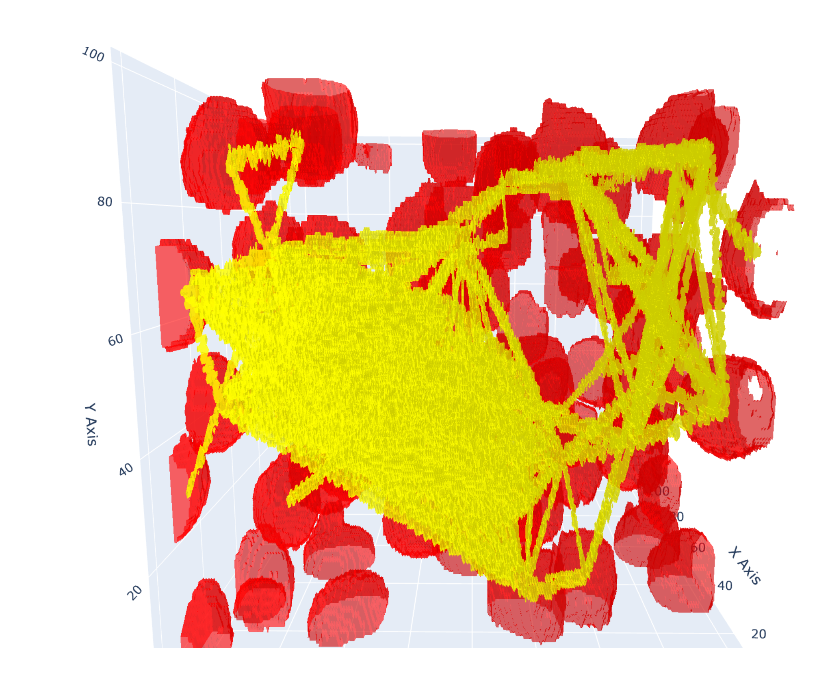

*Above: Output from the show_3D() implementation above. Using show_3D() on other arrays allows us to combine overlays with our Network_3D objects. This can be useful, for example, for showing the network lattice overlay (in yellow above) together with nodes.*

**Altering Network_3D Objects Once Calculated**

There are several methods relating to altering aspects of Network_3D objects post-calculation, to allow the user to manipulate and tweak the objects according to their needs. The following methods relate to manipulating the size of the Network_3D object.

|  |
| --- |
| def downsample(self, down_factor):  """  Downsamples the Network_3D object (and all its properties) by some specified factor, to make certain associated methods faster. Centroid IDs and voxel scalings are adjusted accordingly.  :param down_factor: (Mandatory, int). The factor by which to downsample the Network_3D object.  """  def rescale(self, array, directory = None):  """  Scale a downsampled overlay or extracted image object back to the size that is present in either a Network_3D's node or edge properties.  This will allow a user to create downsampled outputs to speed up certain methods when analyzing Network_3D objects, but then scale them back to the proper size of that corresponding object.  This will be saved to the active directory if none is specified.  :param array: (Mandatory; string or ndarray). A path to the .tif file to be rescaled, or an numpy array of the same.  :param directory: (Optional - Val = None; string). A path to a directory to save the rescaled output.  """  def upsample(self, up_factor, targ_shape):  """  Upsamples the Network_3D object (and all its properties) by some specified factor, usually to undo a downsample. Centroid IDs and voxel scalings are adjusted accordingly.  Note that the upsample also asks for a target shape in the form of a tuple (Z, Y, X) (which can be obtained from numpy arrays as some_array.shape).  This is because simply upsampling by a factor that mirrors a downsample will not result in the exact same shape, so the target shape is also requested. Note that this method  should only be called to undo downsamples by an equivalent factor, while inputting the original shape prior to downsampling in the targ_shape param. This method is not a general purpose rescale method  and will give some unusual results if the up_factor does not result in an upsample whose shape is not already close to the targ_shape.  :param up_factor: (Mandatory, int). The factor by which to upsample the Network_3D object.  :targ_shape: (Mandatory, tuple). A (Z, Y, X) tuple of the target shape that should already be close to the shape of the upsampled array.  """ |

Downsampling will shrink the nodes, edges, and search_region properties in each dimension by the specified factor and is a good way to speed up any processing, presuming the resulting array is not over-downsampled (for example, labelled objects smaller than the downsample in one of their dimensions are at risk of being removed from the array). The method rescale() meanwhile allows us to input some other array and scale it up to the exact size of the arrays stored in some Network_3D object. This method is meant to be utilized with any method that creates a downsampled overlay, that the user then wants to restore to the original size. Like always, the directory param takes a string pointing to a folder to save data to, otherwise the active directory will be used. Finally, upsample() can be used to enlarge Network_3D objects, and is primarily meant to undo downsamples rather than for computing general enlargements (as there is not really any reason to enlarge a Network_3D object as a first step). The upsample() method likewise needs to take an ‘up_factor’ equivalent to the ‘down_factor’ used for a downsample, alongside a ‘targ_shape’, which is the .shape property of the arrays stored in the original Network_3D object. Implementation may look like:

|  |
| --- |
| my_network = n3d.Network_3D()  my_network.assemble('dump')  my_network.draw_network(down_factor = 5) #I draw a downsampled network lattice overlay  original_shape = my_network.nodes.shape #I use the ndarray shape property to store the original shape  my_network.downsample(5) #And I shrink my Network_3D object to match the overlay  my_network.show_3D(other_arrays = 'drawn_network.tif') #And visualize  my_network.upsample(5, original_shape) #But perhaps I do want the original size  my_network.rescale('drawn_network') #I can scale then scale the overlay to match the size of my Network_3D object. |

We also have a few methods pertaining to manipulating the network property in post:

|  |
| --- |
| def remove_edge_weights(self):  """  Remove the weights from a network. Requires _network object to be calculated. Removes duplicates from network_list and removes weights from any network object.  Note that by default, ALL nodes that have duplicate connections through alternative edges will have a network with weights that correspond to the number of  these connections. This will effect some networkx calculations. This method may be called on a Network_3D object to eliminate these weights, assuming only discrete connections are wanted for analysis.  """  def edge_to_node(self):  """  Converts all edge objects to node objects. Oftentimes, one may wonder how nodes are connected by edges in a network. Converting nodes to edges permits this visualization.  Essentially a nodepair A-B will be reassigned as A-EdgeC and B-EdgeC.  Alters the network and network_lists properties to absorb all edges. Edge IDs are altered to not overlap preexisting node IDs. Alters the edges property so that labels correspond  to new edge IDs. Alters (or sets, if none exists) the node_identities property to keep track of which new nodes are 'edges'. Alters node_centroids property to now contain edge_centroids.  """  def trunk_to_node(self):  """  Converts the edge 'trunk' into a node. In this case, the trunk is the edge that creates the most node-node connections. There may be times when many nodes are connected by a single, expansive edge that obfuscates the rest of the edges. Converting the trunk to a node can better reveal these edges.  Essentially a nodepair A-B that is connected via the trunk will be reassigned as A-Trunk and B-Trunk.  Alters the network and network_lists properties to absorb the Trunk. Alters (or sets, if none exists) the node_identities property to keep track of which new nodes is a 'Trunk'.  """  def remove_trunk_post(self):  """  Removes the 'edge' trunk from a network. In this case, the trunk is the edge that creates the most node-node connections. There may be times when many nodes are connected by a single, expansive edge that obfuscates the rest of the edges. Removing the trunk to a node can better reveal these edges.  Alters the network and network_lists properties to remove the Trunk.  """ |

Execution of these methods is straightforward as they all have no parameters. The method remove_edge_weights() allows us to remove the weighted components of the network property, presuming we are only interested in the status of any connections between nodes, rather than quantities of connections. Note this will also remove duplicates from the network_lists property. The method edge_to_node() is interesting, as it converts every indexed edge into a node within the network and network_lists properties, while also updating node_centroids to contain all edge_centroids and indexing edges within the node_identities property. This method can be called if the user wishes to visualize the exact nature of node-to-node connections, including describing the location of edge objects in space (especially when enabling the ‘geometric’ param in network visualization methods), since edges themselves may represent some biological structure. The method trunk_to_node() works the same way, but only converts the single most node-connecting edge into a node, which can be useful in visualizing secondary connections beyond trunk objects (such as large nerve bundles). Finally, remove_trunk_post() simply removes the trunk entirely. Note that removing the trunk during calculation of a Network_3D object takes a slightly different approach, instead removing the largest-by-volume edge.

|  |
| --- |
| trunk_network = my_network.copy() #A deepcopy lets me explore different tweaks  edge_network = my_network.copy()  trunk_network.trunk_to_node() #Now I can visualize it without the trunk making a big knot  trunk_network.show_identity_network()  my_network.remove_trunk_post() #Or maybe I just want the trunk gone.  my_network.show_communities_louvain()  my_network.remove_edge_weights() #I can de-weight my network  edge_network.edge_to_node() #Now I can see what all the edges are up to.  edge_network.show_identity_network(geometric = True) |

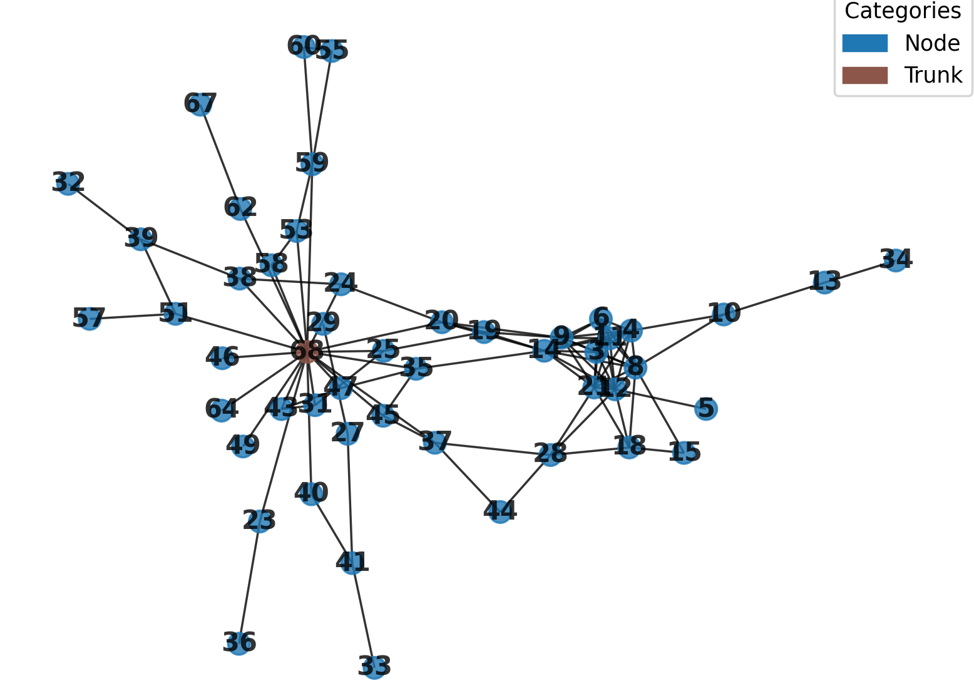

*Above: The output from show_identity_network() for the trunk_network variable after it has been altered by trunk_to_node(). The ‘trunk’ shown is the single most interconnected edge in the image.*

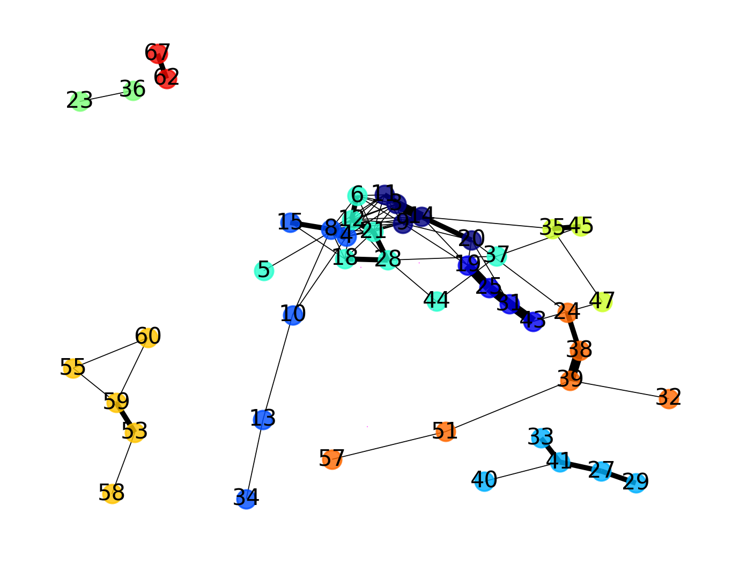

*Above: The output from show_identity_network() for the my_network variable after it has been altered by remove_trunk_post(). The ‘trunk’ in question has been removed, causing downstream components to split up a little bit. Note that these results differ slightly from instead removing the trunk during calculate_all(), since it finds the trunk based on connectivity, while the former uses the size of the object in question.*

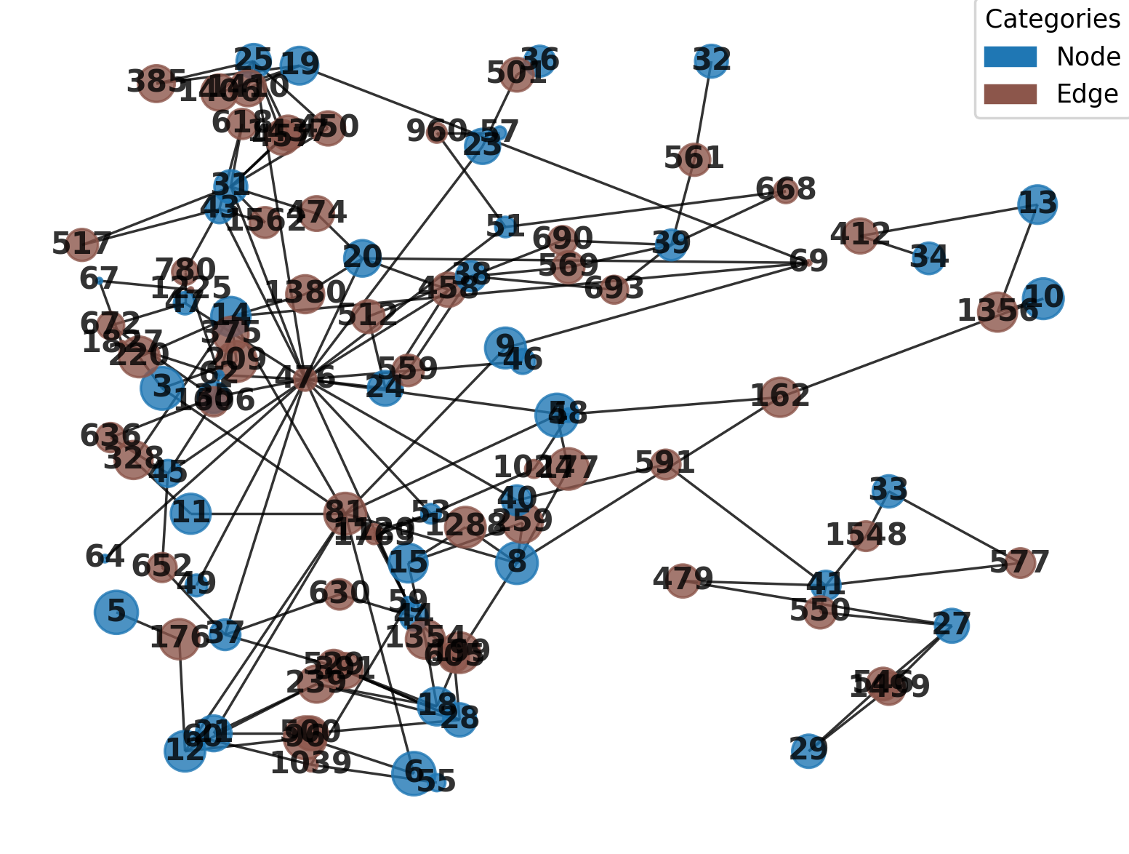

*Above: The output from show_identity_network() for the edge_network variable after it has been altered by edge_to_node(). Note that because ‘geometric’ was set to True, all edges are shown at their actual centerpoints.*

There are also two methods related to interacting with nodes of different identities:

|  |
| --- |
| def prune_samenode_connections(self):  """  If working with a network that has multiple node identities (from merging nodes or otherwise manipulating this property),  this method will remove from the network and network_lists properties any connections that exist between the same node identity,  in case we want to investigate only connections between differing objects.  """  def isolate_internode_connections(self, ID1, ID2):  """  If working with a network that has at least three node identities (from merging nodes or otherwise manipulating this property),  this method will isolate only connections between two types of nodes, as specified by the user,  in case we want to investigate only connections between two specific node types.  :param ID1: (Mandatory, string). The name of the first desired nodetype, as contained in the node_identities property.  :param ID2: (Mandatory, string). The name of the second desired nodetype, as contained in the node_identities property.  """ |

The method prune_samenode_connections() alters the network/network_lists properties and lets us focus on only connections that exist between nodes of separate identities by removing connections amidst nodes of the same identity. The method isolate_internode_connections() meanwhile alters the network/network_lists properties so that they only contain connections between two specific objects (specified to the params ID1 and ID2 as strings equivalent to the names in the node_identities property). This way, if we have three or more node types in one network, we can take time exploring the connectivity of specific pairings.

|  |
| --- |
| identity_network = n3d.Network_3D()  identity_network.assemble('identity_dump') # I load my network that has multiple node identities  other_network = identity_network.copy() #Create a copy to edit differently  other_network.prune_samenode_connections() #In the copy, I remove all connections between nodes of the same type  other_network.show_identity_network()  identity_network.edge_to_node() #In the original, I convert the edges to nodes  identity_network.isolate_internode_connections('Ducts', 'Edge') #Finally, I have the network isolate only connections between edges and my first node type.  identity_network.show_identity_network() |

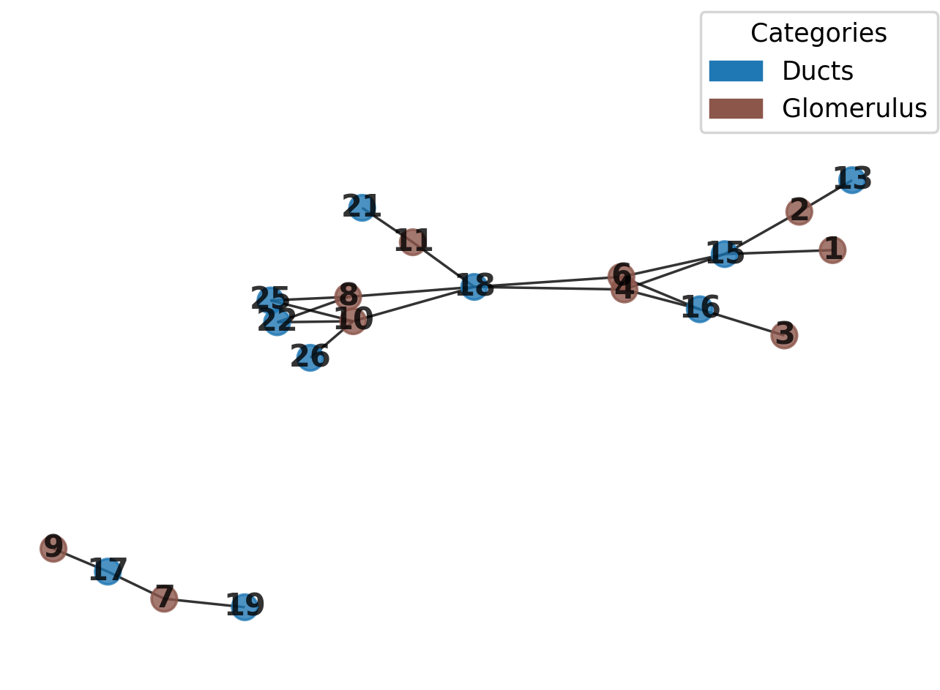

*Above: The output from show_identity_network() for the other_network variable after it has been altered by prune_samenode_connections(), for our Network_3D() objects containing both the glomeruli and collecting ducts. Now, all connections between two of the same node type have been removed.*

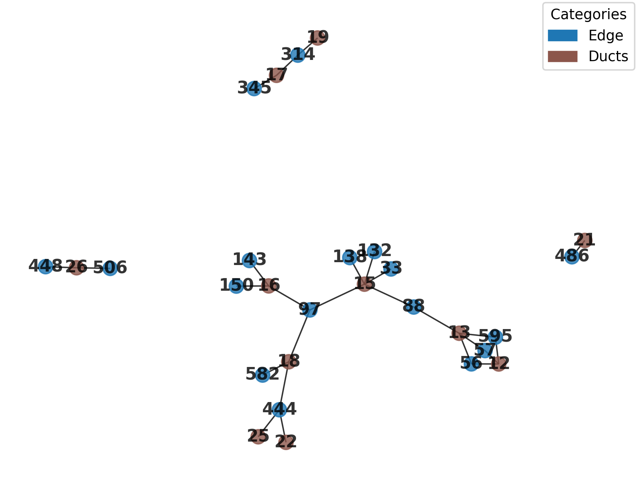

*Above: The output from show_identity_network() for the identity_network variable after it has been altered by edge_to_node() followed by isolate_internode_connections(), for our Network_3D() objects containing both the glomeruli and collecting ducts. Now, only nodes of the designated IDs have been retained (in this case, edges and ducts). Note that an edge that passes through a ‘glomerulus’ node on its way between two ducts will now show a broken path.*

**Methods Related to Extracting 3D Visual Information from Network_3D Objects**

Several methods allow us to extract information about nodes from Network_3D objects as overlays, combining network information with 3D morphology. The methods documented below pertain purely to getting information about nodes:

|  |
| --- |
| def get_degrees(self, down_factor = 1, directory = None):  """  Method to obtain information on the degrees of nodes in the network, also generating overlays that relate this information to the 3D structure.  Overlays include a grayscale image where nodes are assigned a grayscale value corresponding to their degree, and a numerical index where numbers are drawn at nodes corresponding to their degree.  These will be saved to the active directory if none is specified. Note calculations will be done with node_centroids unless a down_factor is passed. Note that a down_factor must be passed if there are no node_centroids.  :param down_factor: (Optional - Val = 1; int). A factor to downsample nodes by while calculating centroids, assuming no node_centroids property was set.  :param directory: (Optional - Val = None; string). A path to a directory to save outputs.  :returns: A dictionary of degree values for each node.  """  def get_hubs(self, proportion = None, down_factor = 1, directory = None):  """  Method to isolate hub regions of a network (Removing all nodes below some proportion of highest degrees), also generating overlays that relate this information to the 3D structure.  Overlays include a grayscale image where nodes are assigned a grayscale value corresponding to their degree, and a numerical index where numbers are drawn at nodes corresponding to their degree.  These will be saved to the active directory if none is specified. Note calculations will be done with node_centroids unless a down_factor is passed. Note that a down_factor must be passed if there are no node_centroids.  :param proportion: (Optional - Val = None; Float). A float of 0 to 1 that details what proportion of highest node degrees to include in the output. Note that this value will be set to 0.1 by default.  :param down_factor: (Optional - Val = 1; int). A factor to downsample nodes by while calculating centroids, assuming no node_centroids property was set.  :param directory: (Optional - Val = None; string). A path to a directory to save outputs.  :returns: A dictionary of degree values for each node above the desired proportion of highest degree nodes.  """  def isolate_mothers(self, directory = None, down_factor = 1, louvain = True):  """  Method to isolate 'mother' nodes of a network (in this case, this means nodes that exist betwixt communities), also generating overlays that relate this information to the 3D structure.  Overlays include a grayscale image where mother nodes are assigned a grayscale value corresponding to their degree, and a numerical index where numbers are drawn at mother nodes corresponding to their degree, and a general grayscale mask with mother nodes having grayscale IDs corresponding to those stored in the nodes property.  These will be saved to the active directory if none is specified. Note calculations must be done with node_centroids.  :param down_factor: (Optional - Val = 1; int). A factor to downsample nodes by while drawing overlays. Note this option REQUIRES node_centroids to already be set.  :param directory: (Optional - Val = None; string). A path to a directory to save outputs.  :param louvain: (Optional - Val = True; boolean). If True, louvain community detection will be used. Otherwise, label propogation will be used.  :returns: A dictionary of mother nodes and their degree values.  """  def extract_communities(self, directory = None, down_factor = 1, color_code = True):  """  Method to generate overlays that relate community detection in a network to the 3D structure.  Overlays include a grayscale image where nodes are assigned a grayscale value corresponding to their community, a numerical index where numbers are drawn at nodes corresponding to their community, and a  color coded overlay where a nodes color corresponds to its community. Community detection will be done with label propogation.  These will be saved to the active directory if none is specified.  :param directory: (Optional - Val = None; string). A path to a directory to save outputs.  :param down_factor: (Optional - Val = 1; int). A factor to downsample nodes by while drawing overlays. Note this option REQUIRES node_centroids to already be set.  :param color code: (Optional - Val = True; boolean). If set to False, the color-coded overlay will not be drawn.  :returns: A dictionary where nodes are grouped by community.  """  def extract_communities_louvain(self, directory = None, down_factor = 1, color_code = True):  """  Method to generate overlays that relate community detection in a network to the 3D structure.  Overlays include a grayscale image where nodes are assigned a grayscale value corresponding to their community, a numerical index where numbers are drawn at nodes corresponding to their community, and a  color coded overlay where a nodes color corresponds to its community. Community detection will be done with louvain algorithm.  These will be saved to the active directory if none is specified.  :param directory: (Optional - Val = None; string). A path to a directory to save outputs.  :param down_factor: (Optional - Val = 1; int). A factor to downsample nodes by while drawing overlays. Note this option REQUIRES node_centroids to already be set.  :param color code: (Optional - Val = True; boolean). If set to False, the color-coded overlay will not be drawn.  :returns: A dictionary where nodes are grouped by community.  """ |

The method get_degrees() can be used to easily explore the degrees (number of connections) of all nodes, with nodes in the resulting overlay having grayscale values corresponding to their degree. Similarly, get_hubs() functions the same, but only keeps the highest-degree proportion of the nodes passed to the ‘proportion’ param (as a 0-1 float), with 0.1 being used by default. The method isolate_mothers() only retains nodes that exist between communities in the array and can help us find junction points between semi-autonomous community components. Finally, the method extract_communities() allows us to visualize community structure in 3D, with a color-coded, community-divided 3D overlay being generated. As before, the default version uses label-propagation to detect communities, while the Louvain option uses Louvain detection. For all these methods, the directory param takes a string to a directory to save the outputs (or the active directory will be used), while down_factor allows an in-method downsample to be utilized to speed up processing (and as always, a down_factor larger than the smallest dimension of the smallest node risks losing nodes from the outputs).

In general, these methods return overlays of the following:

1. An overlay isolating nodes related to the method in question, with remaining nodes retaining their grayscale labels exactly as indicated in the original nodes property.
2. An overlay isolating nodes, where the isolated nodes have grayscale values that have been altered to instead be equivalent to the degree (number of connections) of the node. These overlays allow us to simply identify where hubs are in the network by looking for the brightest regions, or isolate them in code.
3. An overlay containing drawn numerical values in the place of isolated nodes, equivalent to the nodes’ degree. This provides an alternative way to look for hubs.
4. Not an overlay, but a .xlsx file containing the nodes in question.

The methods relating to extracting communities furthermore have the option to be color coded if the color_code ‘param’ is not changed from its default True value. Finally, all these methods return some kind of informational value, typically a dictionary.

|  |
| --- |
| my_network.downsample(5) #Since my nodes are large, I can downsample to speed things up  my_network.get_degrees() #Overlays with information about the degrees of my nodes  my_network.extract_communities() #Uses label-propogation  my_network.isolate_mothers(louvain = True) #Overlays with nodes that exist between communities. Set louvain to false if you want to match the default extract_communities() output  my_network.load_nodes(file_path = 'mother_nodes.tif') #I can load in the mother nodes as my Network_3D nodes and do stuff to them using Network_3D methods.  my_network.get_hubs(proportion = 0.1) #For example, this will now create the top 10% most interconnected 'mother nodes' |

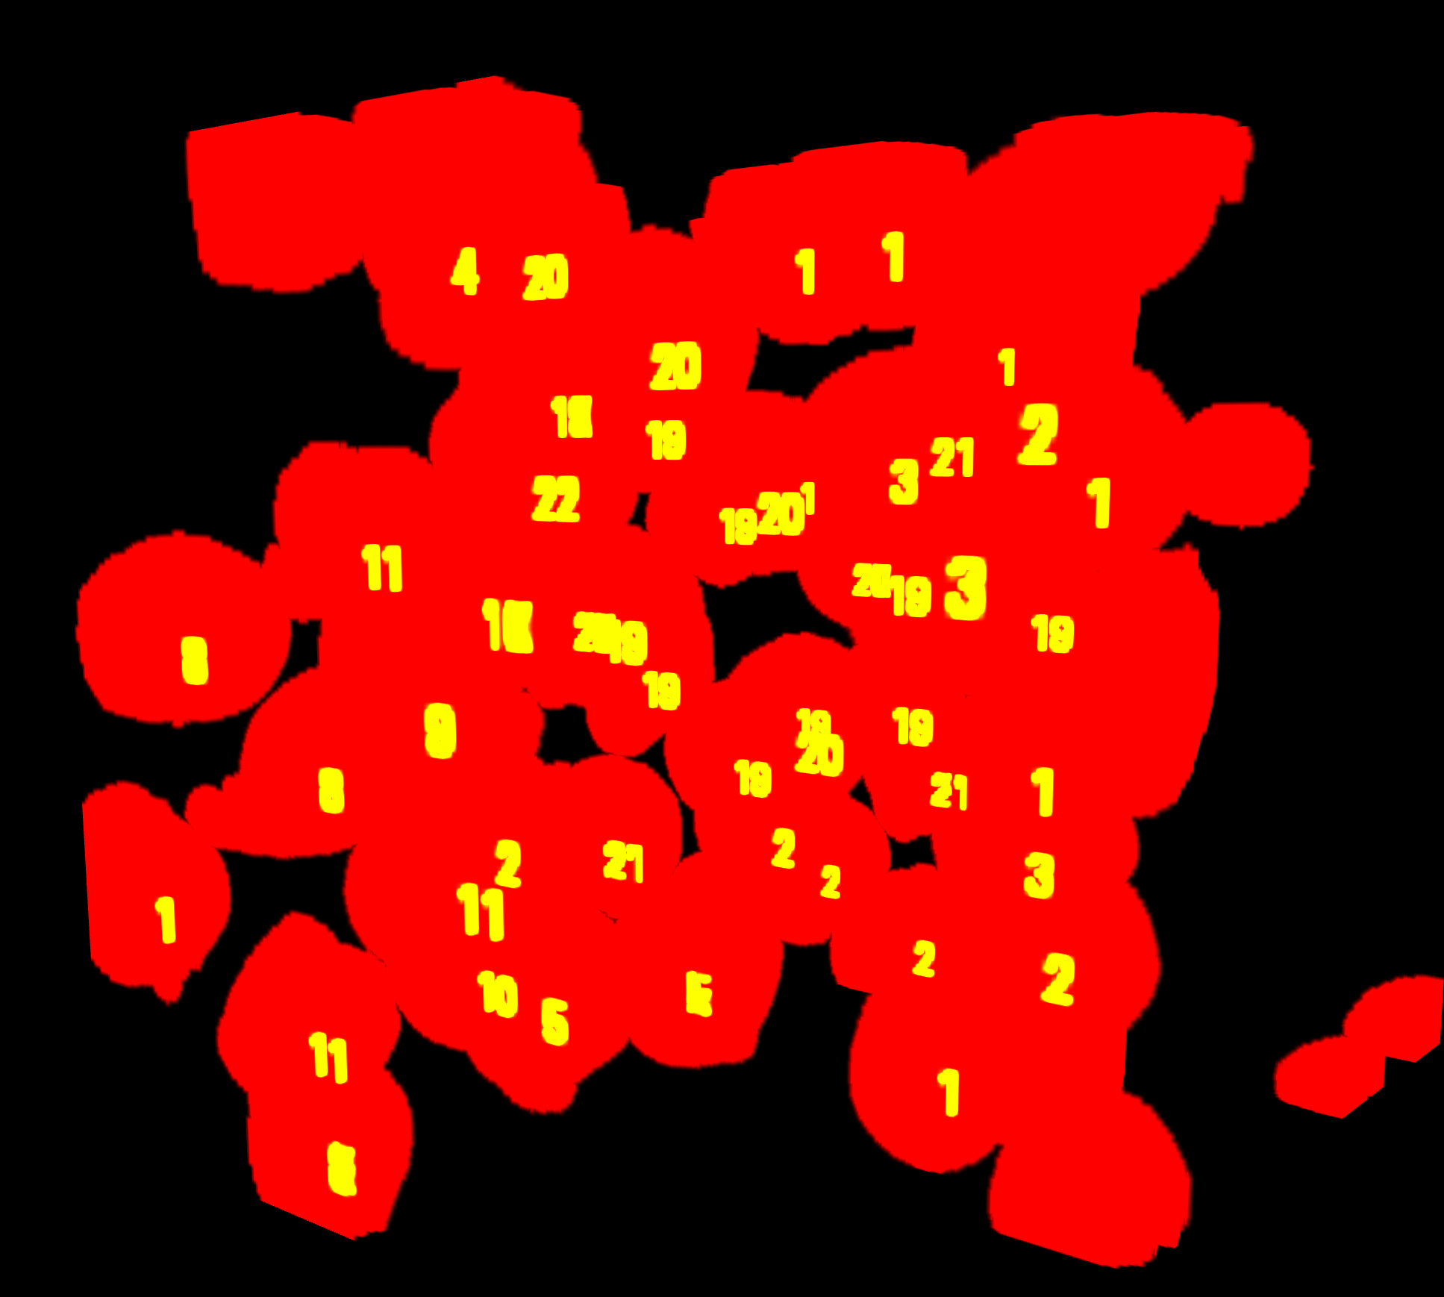

*Above: The glomerulus mask for our lightsheet image overlayed with the labels for the degrees of each node.*

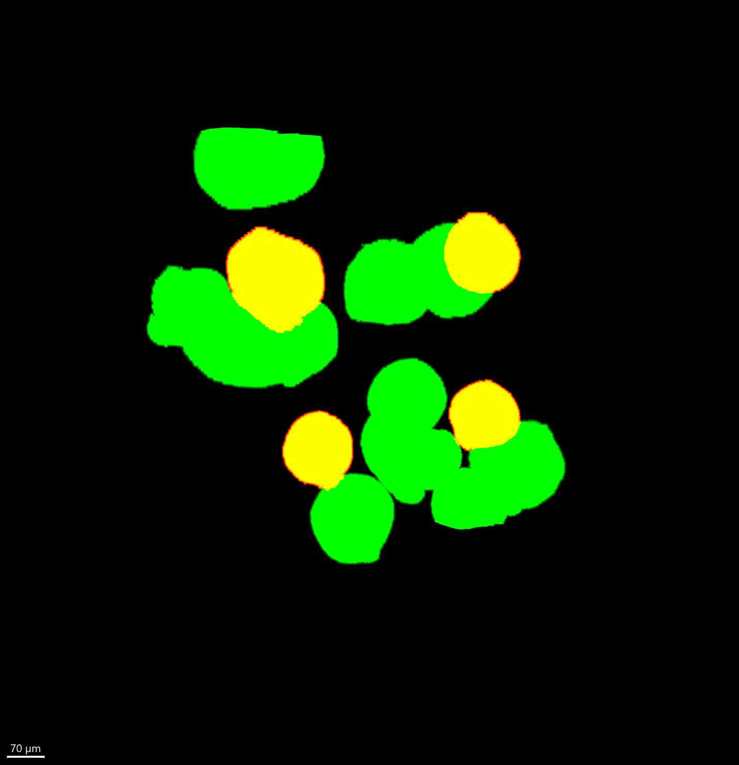

*Above: The mask for ‘mother’ nodes (in between two communities) of the previously shown glomerulus mask in green, while those ‘mother’ nodes that have degrees within the top 10% of nodes in our image are shown in red (yellow through overlap).*

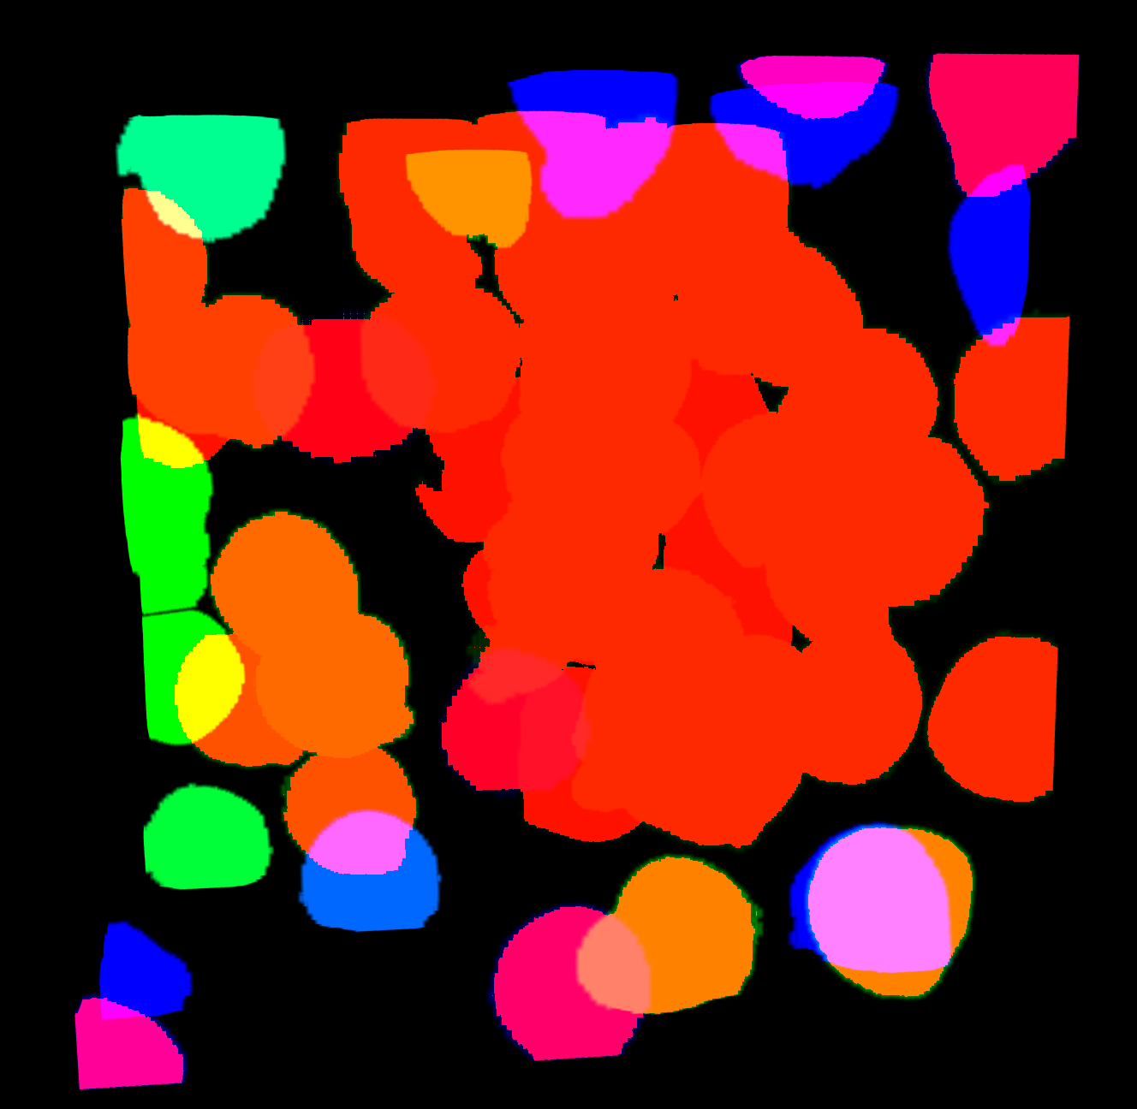

*Above: Colored masks each representing a different community, for visualizing network communities corresponding to our glomerulus mask in 3D.*

Finally, the following method can be used to isolate ‘connected components’ of a network, presuming a Network_3D object has different groups of nodes that do not share any connections. If we want to do deep analysis on one group, the following method can be used to both isolate its network, its edges, and its nodes:

|  |
| --- |
| def isolate_connected_component(self, key = None, directory = None, full_edges = None, gen_images = True):  """  Method to isolate a connected component of a network. This can include isolating both nodes and edge images, primarily for visualization, but will also islate a .xlsx file  to be used to analyze a connected component of a network in detail, as well as returning that networkx graph object. This method generates a number of images. By default,  the isolated component will be presumed to be the largest one, however a key may be passed containing some node ID of any component needing to be isolated.  :param key: (Optional - Val None; int). A node ID that is contained in the desired connected component to be isolated. If unset, the largest component will be isolated by default.  :param directory: (Optional - Val = None; string). A path to a directory to save outputs.  :param full_edges: (Optional - Val = False; string). If None, will not calculate 'full edges' of the connected component. Essentially, edges stored in the edges property will resemble  how this file has been altered for connectivity calculations, but will not resemble true edges as they appeared in their original masked segmentation. To obtain edges, isolated over  a connected component, as they appear in their segmentation, set this as a string file path to your original binary edges segmentation .tif file. Note that this requires the search_region property to be set.  :param gen_images: (Optional - Val = True; boolean). If True, the various isolated images will be generated. However, as this costs time and memory, setting this value to False  will cause this method to only generate the .xlsx file of the connected component and to only return the graph object, presuming the user is only interested in non-visual analytics here.  :returns: IF NO EDGES ATTRIBUTE (will return isolated_nodes, isolated_network in that order. These components can be used to directly set a new Network_3D object  without using load functions by setting multiple params at once, ie my_network.nodes, my_network.network = old_network.isolate_connected_component()). IF EDGES ATTRIBUTE (will  return isolated nodes, isolated edges, and isolated network in that order). IF gen_images == False (Will return just the network).  """ |

This method has a few params that alter its functionality. The ‘key’ param takes an int value that is equivalent to the numerical ID of some node in the network. Passing a node of some ID will isolate the component that this particular node exists in. Passing nothing to ‘key’ will always isolate the largest component instead. As edges will slightly alter their appearance during Network_3D calculation, if the user wants to isolate edges exactly as the originally appeared, the param ‘full_edges’ must be set to a string pointing to the original binary edge segmentation mask that was used to generate the Network_3D object. Like always, the directory param can be passed a string file path to some folder to save outputs, otherwise the active directory will be used. Note that these methods will return a variety of isolated components that can be used to generate a new Network_3D object on the isolated components. Finally, as the overlays and such may take some time and memory to generate, the ‘gen_images’ param can be set to False, which will cause image generation to be skipped and only the network (G) component to be returned for some analysis. Example implementation:

|  |
| --- |
| identity_network = n3d.Network_3D()  iso_network = n3d.Network_3D() #Set up a place to store my isolated network  identity_network.assemble('identity_dump') #Assemble my first network  iso_network.nodes, iso_network.edges, iso_network.network = identity_network.isolate_connected_component(directory = 'outputs', full_edges = 'Nerves_2.tif') #By passing full_edges the path to my original binary edges, I can save their isolated region exactly how it should look. Note I also pass the return statements to properties of my iso_network object, so I can now analyze that like a new Network_3D object  iso_network.calculate_node_centroids(down_factor = 5) #With the new isolated network, I can recompute additional properties I may need  iso_network.calculate_edge_centroids(down_factor = 5)  iso_network.calculate_search_region() #etc  iso_network.load_node_identities('identity_dump')  iso_network.show_identity_network()  iso_key_network = n3d.Network_3D() #Above I managed to isolate the largest component, but I may actually want a specific one.  iso_key_network.network = identity_network.isolate_connected_component(key = 17, gen_images = False) #I pass key 15 so the component with node 15 will be isolated. I also set gen_images to false, as I may not need that information.  iso_key_network.save_network() #I can save this network now or do other things with it  iso_key_network.load_node_identities('identity_dump')  iso_key_network.show_identity_network() |

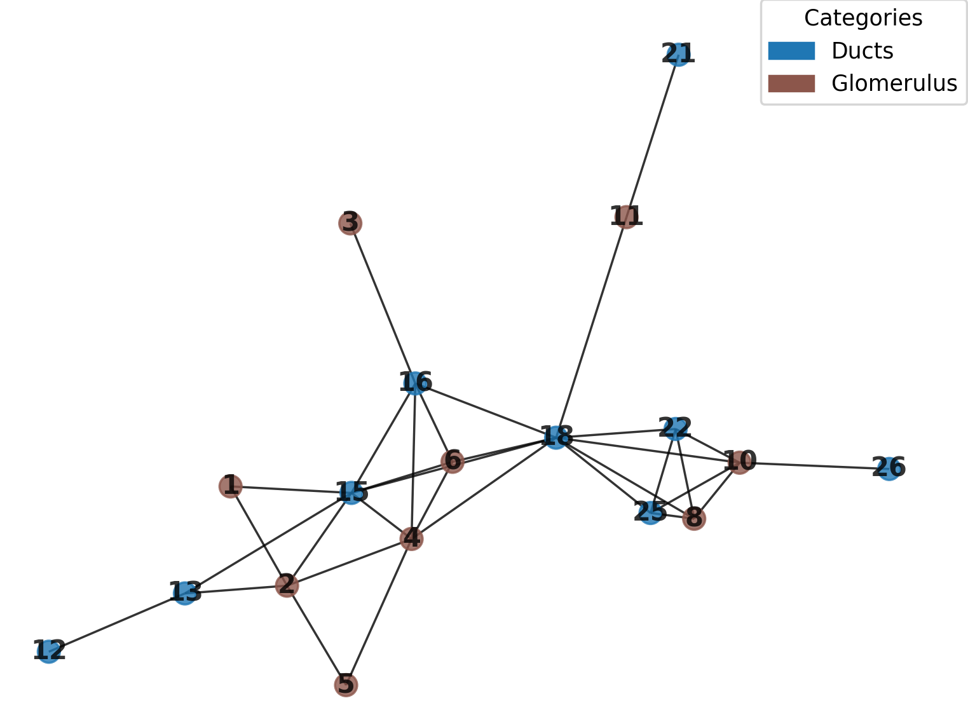

*Above: From our image containing both nodes and collecting ducts, we have isolated the network component of the largest connected component in the network.*

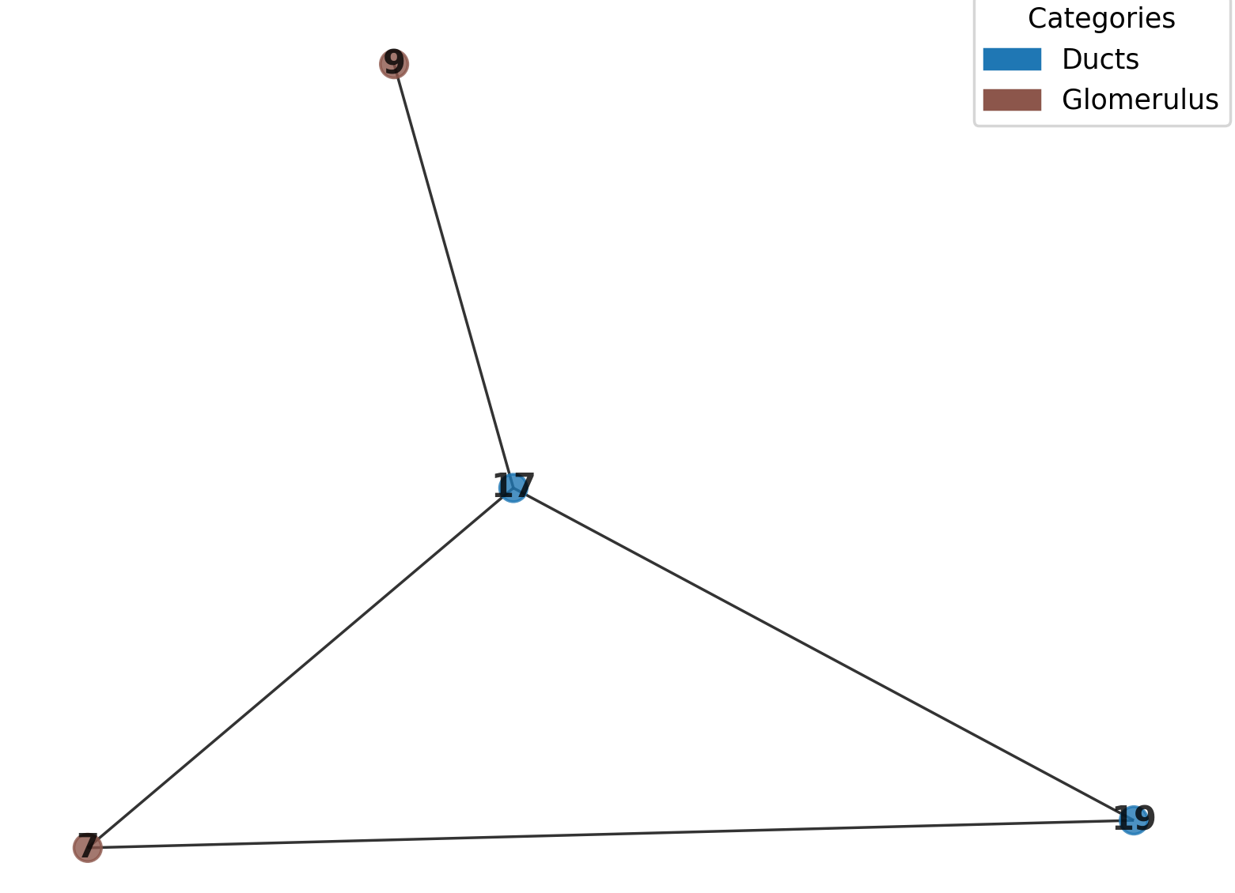

*Above: By passing the corresponding node ID to ‘key’, we can instead isolate a smaller component for whatever analysis.*

**Methods Related to Mathematical Analysis of Network_3D Objects**

A few methods pertain to directly analyzing purely mathematical aspects of the Network_3D objects, as opposed to morphological ones. These methods are shown below:

|  |
| --- |
| def radial_distribution(self, radial_distance, directory = None):  """  Method to calculate the radial distribution of all nodes in the network. Essentially, this is a distribution of the distances between  all connected nodes in the network, grouped into histogram buckets, which can be used to evaluate the general distances of node-node connectivity. Also displays a histogram.  This method will save a .xlsx file of this distribution (not bucketed but instead with all vals) to the active directory if none is specified.  :param radial_distance: (Mandatory, int). The bucket size to group nodes into for the histogram. Note this value will correspond 1-1 with voxels in the nodes array if xy_scale/z_scale have not been set, otherwise they  will correspond with whatever true value the voxels represent (ie microns).  :param directory: (Optional - Val = None; string): A path to a directory to save outputs.  :returns: A list of all the distances between connected nodes in the network.  """  def assign_random(self, weighted = True):  """  Generates a random network of equivalent edge and node count to the current Network_3D object. This may be useful, for example, in comparing aspects of the Network_3D object  to a similar random network, to demonstrate whether the Network_3D object is a result that itself can be considered random. For example, we can find the modularity of the  random network and compare it to the Network_3D object's modularity. Note that the random result will itself not have a consistent modularity score between instances this  method is called, due to randomness, in which case iterating over a large number, say 100, of these random networks will give a tighter comparison point. Please note that  since Network_3D objects are weighted for multiple connections by default, the random network will consider each additional weight as an additional edge. So a network that has  one edge of weight one and one of weight two will cause the random network to incorperate 3 edges (that may be crunched into one weighted edge themselves). Please call remove_edge_weights()  on the Network_3D() object prior to generating the random network if this behavior is not desired.  :param weighted: (Optional - Val = True; boolean). By default (when True), the random network will be able to take on edge weights by assigning additional edge  connections between the same nodes. When False, all edges will be made to be discrete. Note that if you for some reason have a supremely weighted network and want to deweight  the random network, there is a scenario where no new connections can be found and this method will become caught in a while loop.  :returns: an equivalent random networkx graph object  """  def degree_distribution(self, directory = None):  """  Method to calculate the degree distribution of all nodes in the network. Essentially, this is recomputes the distribution of degrees to show an x axis of degrees in the network,  and a y axis of the proportion of nodes in the network that have that degree. A .xlsx file containing the degree distribution will be saved to the active directory if none is specified.  This method also shows a scatterplot of this result and attempts to model a power-curve over it, however I found the excel power-curve modeler to be superior so that one may be more reliable than the one included here.  :param directory: (Optional - Val = None; string): A path to a directory to save outputs.  :returns: A dictionary with degrees as keys and the proportion of nodes with that degree as a value.  """ |

The first method, radial_distribution(), is useful for evaluating the general distances of node-node connections in the network. Running this method on a Network_3D object returns an excel file containing the distance between every connected node, in addition to displaying a histogram of bucketed distances. The param ‘radial_distance’ represents the size of the buckets, being one-to-one with voxels if the xy_scale and z_scale are their default values of 1, but otherwise representing the true distance unit of the image.

The second method, assign_random(), generates a random network equivalent to the network stored in the Network_3D object. The random network contains the same amount of edges and nodes (keep in mind that weights in the Network_3D object’s network increase the number of connections available for the random network). The random network contains the param ‘weighted’, which allows the random network to become weighted when assigned its default True value, but will not create a weighted network when False. The random network can be useful to demonstrate that properties of some Network_3D object are unlikely (or otherwise are likely) to have resulted from randomness. For example, I can compare the modularity of my random network to the original, although it may be best to iteratively average the modularities of several random networks, since modularity itself will fluctuate with the random generation.

The final method, degree_distribution(), evaluates the degrees of nodes in the network property. Rather than returning a set of degrees like the degrees() method, degree_distribution() returns a dictionary where the key is the proportion of nodes with some degree (p(k)), while the value is the degree in question k. A scatterplot modeled with a power-curve is also shown and an excel file is saved containing the same data, although the excel power-curve trendline may be more accurate. In general, the existence of a fat tailed distribution where the majority of nodes are of low degree indicates the existence of a hub and spoke network structure.

|  |
| --- |
| from nettracer3d import nettracer as n3d  my_network.radial_distribution(directory = 'output', radial_distance = 100)  my_network.degree_distribution(directory = 'output')  original_mod = my_network.modularity(solo_mod = True) #The starting modularity of my network  running_mod = 0  for i in range(100): #I iterate to average the modularities of several random equivalent networks  some_network = n3d.Network_3D()  some_network.network = my_network.assign_random()  running_mod += some_network.modularity(solo_mod = True)  random_mod = running_mod/100 #Now random_mod can be compared to original_mod, perhaps in a significance test of some kind |

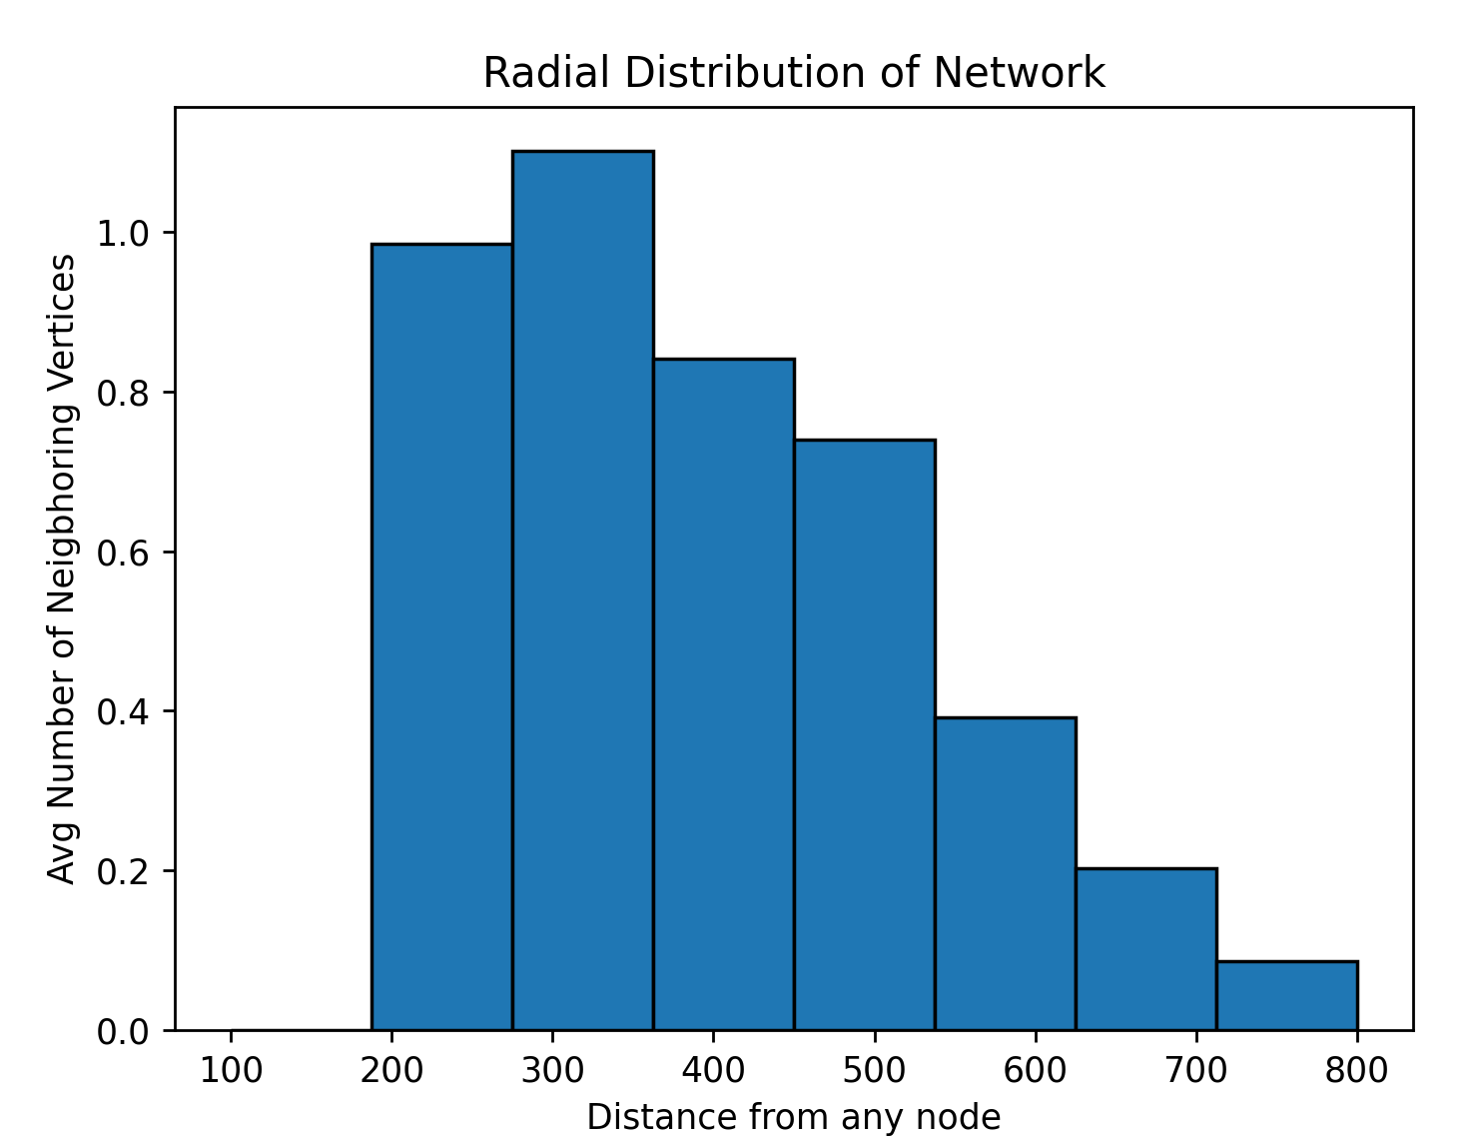

*Above: The radial distribution of the glomeruluses in the Network-3D object, showing most connections exist at a closer rather than more distal distance.*

**v**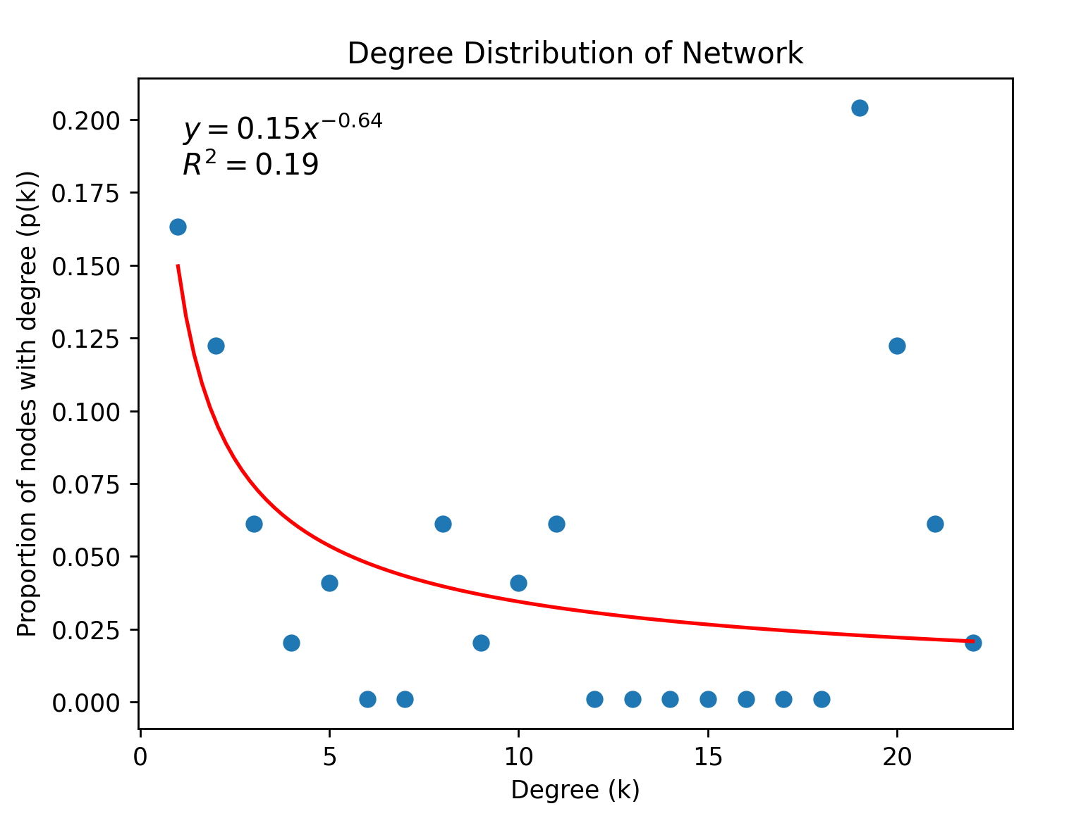

*Above: The degree distribution of the glomeruluses in the Network-3D object, showing a bias for lower-degree nodes. Note that Microsoft Excel will likely do a better job modeling this trendline.*

**Useful Functions Independent of the Network_3D Class**

There are several included functions that are designed to run directly on saved .tif images, process them somehow, and save an output. These functions are those that may be most useful for the pre-and-post-processing of Network_3D components.

|  |
| --- |
| def downsample(data, factor, directory = None):  """  Can be used to downsample an image by some arbitrary factor. Downsampled output will be saved to the active directory if none is specified.  :param data: (Mandatory, string or ndarray) - If string, a path to a tif file to downsample. Note that the ndarray alternative is for internal use mainly and will not save its output.  :param factor: (Mandatory, int) - A factor by which to downsample the image.  :param directory: (Optional - Val = None, string) - A filepath to save outputs.  :returns: a downsampled ndarray.  """  def binarize(arrayimage, directory = None):  """  Can be used to binarize an image. Binary output will be saved to the active directory if none is specified.  :param arrayimage: (Mandatory, string or ndarray) - If string, a path to a tif file to binarize. Output will be 8bit with 0 representing background and 255 representing signal. Note that the ndarray alternative is for internal use mainly and will not save its output, and will also contain vals of 0 and 1.  :param directory: (Optional - Val = None, string) - A filepath to save outputs.  :returns: a binary ndarray.  """  def dilate(arrayimage, amount, xy_scale = 1, z_scale = 1, directory = None):  """  Can be used to dilate a binary image in 3D. Dilated output will be saved to the active directory if none is specified.  :param arrayimage: (Mandatory, string or ndarray) - If string, a path to a tif file to dilate. Note that the ndarray alternative is for internal use mainly and will not save its output.  :param amount: (Mandatory, int) - The amount to dilate the array. Note that if xy_scale and z_scale params are not passed, this will correspond one-to-one with voxels. Otherwise, it will correspond with what voxels represent (ie microns).  :param xy_scale: (Optional; Val = 1, float) - The scaling of pixels.  :param z_scale: (Optional - Val = 1; float) - The depth of voxels.  :param directory: (Optional - Val = None, string) - A filepath to save outputs.  :returns: a dilated ndarray.  """  def skeletonize(arrayimage, directory = None):  """  Can be used to 3D skeletonize a binary image. Skeletonized output will be saved to the active directory if none is specified. Note this works better on already thin filaments and may make mistakes on larger trunkish objects.  :param arrayimage: (Mandatory, string or ndarray) - If string, a path to a tif file to skeletonize. Note that the ndarray alternative is for internal use mainly and will not save its output.  :param directory: (Optional - Val = None, string) - A filepath to save outputs.  :returns: a skeletonized ndarray.  """  def mask(image, mask, directory = None):  """  Can be used to mask one image with another. Masked output will be saved to the active directory if none is specified.  :param image: (Mandatory, string or ndarray) - If string, a path to a tif file to get masked, or an ndarray of the same.  :param mask: (Mandatory, string or ndarray) - If string, a path to a tif file to be a mask, or an ndarray of the same.  :param directory: (Optional - Val = None; string) - A filepath to save outputs.  :returns: a masked ndarray.  """  def label(image, directory = None):  """  Can be used to label a binary image, where each discrete object is assigned its own grayscale value. Labelled output will be saved to the active directory if none is specified.  :param image: (Mandatory, string or ndarray) - If string, a path to a tif file to get masked, or an ndarray of the same.  :param directory: (Optional - Val = None; string) - A filepath to save outputs.  :returns: a labelled ndarray.  """  def filter_by_size(array, proportion=0.1, directory = None):  """  Threshold out objects below a certain proportion of the total volume in a 3D binary array.    :param array: (Mandatory; string or ndarray) - A file path to a 3D binary tif image array with objects or an ndarray of the same.  :param proportion: (Optional - Val = 0.1; float): Proportion of the total volume to use as the threshold. Objects smaller tha this proportion of the total volume will be removed.  :param directory: (Optional - Val = None; string): Optional file path to a directory to save output, otherwise active directory will be used.  :returns: A 3D binary numpy array with small objects removed.  """ |

1. The downsample() function takes three params. The ‘data’ param should be a string path to a .tif file intended to be downsampled. As usual, the ‘down_factor’ param is an int by which the .tif will be multiplicatively shrunk in each dimeniosn. The ‘directory’ param should be a string pointing to an output directory (otherwise the active directory will be used). A downsampled version of the image will be saved. This function will also return the downsampled image as an ndarray, for which an ndarray can also be passed to ‘data’.
2. Many of the overlays above are some form of grayscale, however users may want to use the binarize() function to binarize (which in this case, sets all nonzero voxels to 255 in an 8bit output) these files to make viewing the totality of data optimal in a 3D viewer. Pass a string pointing to the .tif file to binarize to the ‘arrayimage’ param. Param ‘directory’ as usual takes an optional path to a directory. A binarized version of the image will be saved.
3. The dilate() function can be used to expand binary objects in an image to explore, for example, how different search region parameters affect nodes in a Network_3D object. The param ‘arrayimage’ takes the string path to your .tif file, while the param ‘amount’ takes the size of dilation to expand all binary data in the image in 3D. The params ‘xy_scale’ and ‘z_scale’ can be passed the corresponding float voxel sizes of your image, in which case ‘amount’ will represent a true distance unit, but otherwise default values of 1 will mean ‘amount’ applies 1:1 with voxels. As always, the directory can also be optionally specified.
4. The skeletonize() function attempts to use 3D skeletonization to reduce a binary mask to its most internal filament. This function is a pretty basic implementation of the skimage skeletonize_3d method. Note that this skeletonization does not work great on very thick masks, but is very good at thinning out filamental regions. Please pass the .tif string path of your image to skeletonize to the ‘arrayimage’ param, with directory specification being optional.
5. The mask() function can be used to isolate positive signal in one image that overlap with the positive binary signal of another image. Please pass the string path to the .tif needing to be masked to the first param, ‘image’, and pass the string path of the .tif doing the masking to the second param, ‘mask’. Again, directory specification is optional.
6. The label() function will apply the basic grayscale labelling algorithm used within NetTracer3D to a binary image, which can be useful in exploring what labelling will look like, for example. Please path a string file path to the .tif to be labelled to the ‘image’ param, with a string path to a directory being optional.
7. The filter_by_size() function can be used to remove small (perhaps noise-related) components from a binary mask .tif. In practice, this means a user can bring their segmentation straight to NetTracer3D, filter out noise, label remaining objects, and run a Network_3D creation. The first param, ‘array’, takes a string file path to the .tif to filter. The second param, ‘proportion’, takes a 0-1 float value that represents the strength of filtering. Any object that is not larger than said ‘proportion times the total volume of objects in the array’ will be removed. Oftentimes, smaller values such as 0.01 may be ideal for removing particularly small particles while keeping larger ones, although 0.1 is the default setting. As with many functions, downsampling prior to this function if possible can improve speed. Finally, the ‘directory’ param takes an optional string path to an output directory.

There are also a few algorithms available for more complicated labelling schemes. They are documented below:

|  |
| --- |
| def watershed(image, directory = None, proportion = 0.1, GPU = True, smallest_rad = None):  """  Can be used to 3D watershed a binary image. Watershedding attempts to use an algorithm to split touching objects into seperate labelled components. Labelled output will be saved to the active directory if none is specified.  Authors note - My watershed is an overall upgrade of the skimage watershed implementation that leverages some tools I already built for nettracer. This watershed algo can give surprisingly good results.  :param image: (Mandatory, string or ndarray). - If string, a path to a binary .tif to watershed, or an ndarray containing the same.  :param directory: (Optional - Val = None; string) - A filepath to save outputs.  :param proportion: (Optional - Val = 0.1; float) - A zero to one value representing the proportion of watershed 'peaks' that are kept around for splitting objects. Essentially,  making this value smaller makes the watershed break more things, however making it too small will result in some unusual failures where small objects all get the same label.  :param GPU: (Optional - Val = True; boolean). If True, GPU will be used to watershed. Please note this will result in internal downsampling most likely, and overall be very fast.  However, this downsampling may kick small nodes out of the image. Do not use the GPU to watershed if your GPU wants to downsample beyond the size of the smallest node that you  want to keep in the output. Set to False to use the CPU (no downsampling). Note using the GPU + downsample may take around a minute to process arrays that are a few GB while the CPU may take an hour or so.  :param smallest_rad: (Optional - Val = None; int). The size (in voxels) of the radius of the smallest object you want to seperate with watershedding. Note that the  'proportion' param is the affector of watershed outputs but itself may be confusing to tinker with. By inputting a smallest_rad, the algo will instead compute a custom proportion  to use for your data.  :returns: A watershedded, labelled ndarray.  """  def label_vertices(array, directory = None):  """  Can be used to label vertices (where multiple branches connect) a binary image. Labelled output will be saved to the active directory if none is specified. Note this works better on already thin filaments and may over-divide larger trunkish objects.  Note that this can be used in tandem with an edge segmentation to create an image containing 'pseudo-nodes', meaning we can make a network out of just a single edge file.  :param array: (Mandatory, string or ndarray) - If string, a path to a tif file to label. Note that the ndarray alternative is for internal use mainly and will not save its output.  :param directory: (Optional - Val = None; string) - A filepath to save outputs.  :returns: an ndarray with labelled vertices.  """  def label_branches(array, down_factor = None, directory = None):  """  Can be used to label branches a binary image. Labelled output will be saved to the active directory if none is specified. Note this works better on already thin filaments and may over-divide larger trunkish objects.  :param array: (Mandatory, string or ndarray) - If string, a path to a tif file to label. Note that the ndarray alternative is for internal use mainly and will not save its output.  :param down_factor: (Optional, Val = None; int) - An optional factor to downsample internally to speed up computation. Note that this method will try to use the GPU if one is available, which may  default to some internal downsampling.  :param directory: (Optional - Val = None; string) - A filepath to save outputs.  :returns: an ndarray with labelled branches.  """ |

1. The first function, watershed(), is useful for converting a binary mask of node objects that are fused into separately labelled signal. For example, two spherical objects that are fused together will be separated into two different grayscale labelled nodes. Note that fused binary signal must be morphologically distinct to be separated, so a large, indistinct clump of objects cannot be separated. The ‘image’ param takes a string path to the .tif binary mask to watershed. The ‘directory’ param takes an optional string path to an output directory. The ‘proportion’ param is a 0-1 float that affects the watershedding behavior, with values closer to 0 being more likely to split nodes (although a proportion val that is too low may cause small nodes to be recognized as pieces of larger nodes). The default value of proportion is 0.1 (which seems to work in many cases), however if the user is unsure what to put, they can pass the voxel length of the smallest radius of the smallest node they want to be separated into the output to the param ‘smallest_rad’, after which the program will guess a proportion that will accommodate that level of watershed. The param ‘GPU’ is True and will have the program utilize the GPU (likely with some level of internal downsample for RAM), so long as a CUDA environment with cupy is set up on the machine. Since GPU will likely downsample larger arrays, the user should check this is not causing especially smaller nodes to be removed from the array. Setting GPU to False (or if the GPU cannot be detected/fails), the CPU will be utilized with no downsample, although note this is a difference of under a minute on GPU to something of an hour on CPU on larger test arrays.
2. The function label_vertices() saves a .tif containing labels for the points that several ‘branch-like’ objects come together on filamentous binary masks. This allows us to label the convergence points on something like a nerve segmentation, for example. Ultimately, this means if the user only has an edge mask, such as one containing nerves or blood vessels, they can still segment vertices and use those as nodes together with the binary edges to create a ‘purely-edge-object’ network. Also note that label_vertices() does rely internally on 3D skeletonization, which may not work optimally on particularly thick binary components. The only params are ‘array’, a stringpath to the .tif file to label vertices for, and ‘directory’, an optional string path to an output directory.
3. The function label_branches() is similar to label_vertices(), but labels the branches that are broken off from splitting vertices, rather than the vertices themselves. This offers a different edge labelling scheme for exploring node connectivity. The only params are ‘array’, a stringpath to the .tif file to label vertices for, and ‘directory’, an optional string path to an output directory.

|  |
| --- |
| n3d.watershed('gloms_binary.tif')  n3d.label_branches('Nerves.tif')  n3d.label_verticies('Nerves.tif') |

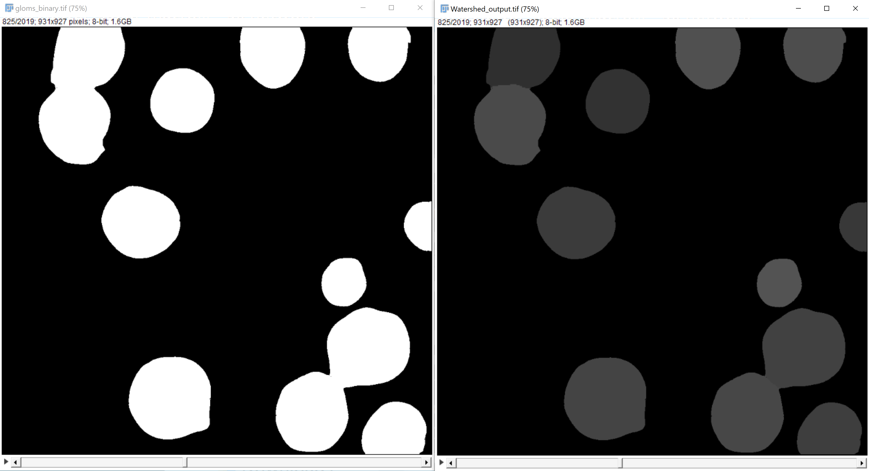

*Above: Before and after NetTracer3D’s watershed() applied on a binary mask. The white objects on the left have all been labelled and properly split (of the four that are fused) as shown in the right, in 3D.*

Finally, we have the function visualize_3D(), which unlike the show_3D() method allows us to visualize any binary .tif (or tifs) regardless of their involvement in a Network_3D object:

|  |
| --- |
| def visualize_3D(array, other_arrays=None, xy_scale = 1, z_scale = 1):  """  Mostly internal method for 3D visualization, although can be run directly on tif files to view them. Uses plotly to visualize  a 3D, binarized isosurface of data. Note this method likely requires downsampling on objects before running.  :param array: (Mandatory; string or ndarray) - Either a path to a .tif file to visualize in 3D binary, or a ndarray of the same.  :param other_arrays: (Optional - Val = None; string, ndarray, or list) - Either a path to a an additional .tif file to visualize in 3D binary or an ndarray containing the same,  or otherwise a path to a directory containing ONLY other .tif files to visualize, or a list of ndarrays containing the same.  :param xy_scale: (Optional - Val = 1; float) - The xy pixel scaling of an image to visualize.  :param z_scale: (Optional - Val = 1; float) - The z voxel depth of an image to visualize.  """ |

The visualize_3D() method works similarly to show_3D, but the first param, ‘array’, will take any string to a .tif to visualize. The second param, other_arrays, can optionally be passed a string filepath to another .tif to visualize, or a directory of .tif files to visualize. Finally, the xy_scale and z_scale params take float values concerning voxel scaling to ensure visualization is morphologically correct. Note that this method does not perform on-line downsampling, so any downsample should be computed prior to using this method to visualize. It will struggle on larger arrays.

|  |
| --- |
| n3d.visualize_3D('other_folder/drawn_network.tif', xy_scale = 0.914, z_scale = 0.496) |

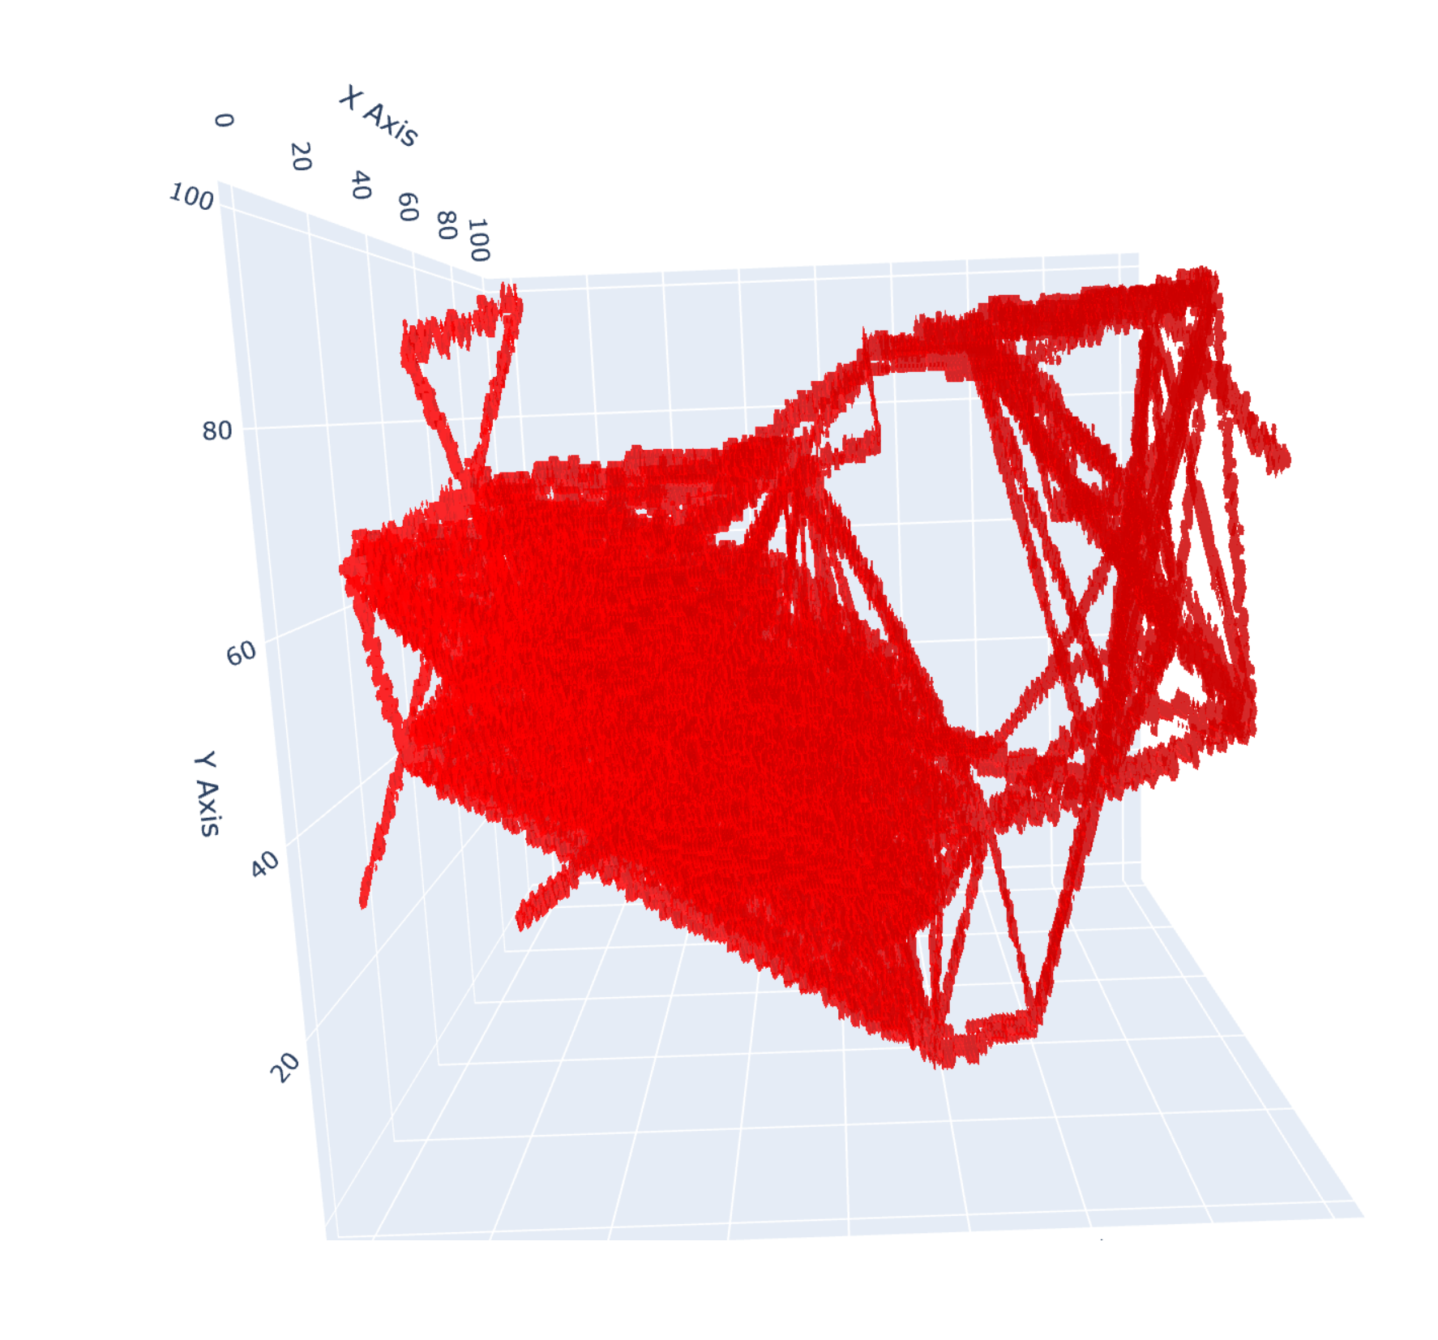

*Above: Example of using visualize_3D() to look at just the network lattice.*

**Other Useful Programs**

**Python**

As mentioned, NetTracer3D (especially in its current headless form) is designed to be primarily a toolkit to allow users to merge its functionality with other Python packages. It is most optimally utilized alongside NetworkX, however commonly useful packages for image analysis such as scipy&numpy (or the GPU-accelerated cupy), skimage, OpenCV, etc, are useful for accessing and manipulating the 3D data components.

**Image Processing**

The most straightforward imaging processing software to use alongside NetTracer3D will be the free program ImageJ (and FIJI, being the upgraded version). There are quite a lot of different applications of FIJI and its swath of plugins. The paid software Imaris is also quite useful for editing/visualizing segmented objects. Namely, once a segmentation has been generated by a tool like labkit (or in Imaris itself), Imaris can be used to create an isosurface along the binary object. This isosurface can be interactively edited, such as deleting or thresholding out noise, used to mask a new binary channel to export, or to create good visualizations or movies. Imaris’s filaments tracer is also quite good at refining filamentous segmentations that could serve as edges, such as nerves. Similar to using surfaces, a filament can be placed overtop a binary segmentation in Imaris, interactively edited, converted into a binary channel with the ‘Create Channel From Filaments’ Xtension, then exported. Although the processing aspects of Imaris require a license, the program ImarisViewer and ImarisChannelConverter can be installed for free to convert .tif files for viewing in Imaris.

**Segmentation**

The FIJI plugin labkit and the free program Cellpose are both good at segmenting out objects for these purposes. The former is a quite flexible segmentation tool that can be used to segment just about anything from an image provided it is distinct from its background, while the latter is good at circling similar-appearing objects (such as cells), and most notably can prelabel clumps of cells (or similar) that would not be watershed-able.

**Image Visualization**

The best image visualization tool will likely be Imaris, whose visualization capabilities can be tested for free using the Imaris Free Viewer. FIJI additionally has a 3D viewer plugin.